Advanced Database Management System ETCS 453

## Faculty: Ms Savita Sharma Name: Anupam Gupta

## Roll No: 00196407220

Semester : 7th



Maharaja Agrasen Institute of Technology, PSP Area, Sector 22, Rohini, New Delhi – 110085

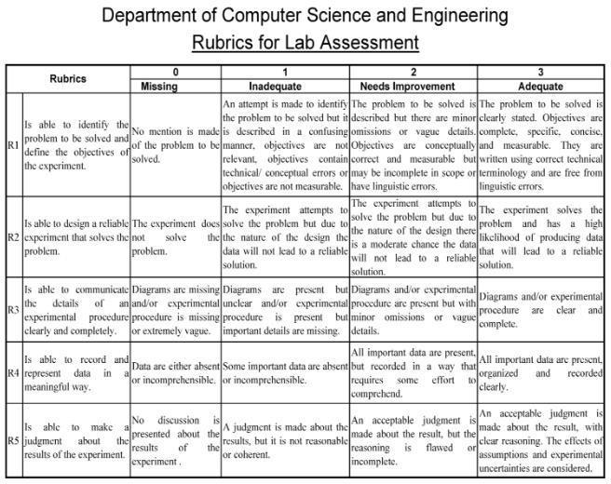

**Index**

| **Exp. no** | **Experiment Name** | **Date of**  **performance** | **Date of checking** | **Marks (10)** | **Signature** |
| --- | --- | --- | --- | --- | --- |
| 1 | (a) Learn to install PostgreSQL.  (b) Compare different Databases such as PostgreSQL, Oracle, MySql and Maria DB. |  |  |  |  |
| 2 | Consider Schema: Student (student_name, enrollment_no, marks, area, branch) Write SQL queries on  a. DDL (eg create, alter, drop, rename, truncate),  b. DML (eg. Insert, update, delete etc.),  c. DCL (eg. Grant, revoke etc.) d. Built-in Functions (eg. Sum, min, max, avg, count, lower, upper, trim, len etc.)  e. Indexes and views: Create and Drop |  |  |  |  |
| 3 | Write SQL queries on Nested queries and Join. |  |  |  |  |
| 4 | PL/SQL  a. write a program to calculate total students enrolled areawise. b. Write a program to calculate average marks obtained by students residing in the area that starts with "R” |  |  |  |  |
| 5 | Cursor  Write the cursor to increase the marks of students by 10%. |  |  |  |  |
| 6 | Exception Handling  Write a program to create exceptions if enrollment no. is not issued to students by the university and raise the exception explicitly by using the raise command. |  |  |  |  |
| 7 | Procedure & Function  a. Write the procedure to get the average marks of students for branch “CSE”.  b. Write a function that accepts branches and returns the total no. of students of the branch. |  |  |  |  |
| 8 | Trigger  a. Create a trigger on the table after inserting a new student into the table.  b. Write a row trigger to insert the existing values of the student table into a new table when the marks of the student are updated. |  |  |  |  |
| 9 | Design Database - Inventory Database(represent for purchase/order details). |  |  |  |  |

**Experiment 1(a) AIM:** Learn to install PostgreSQL

**THEORY:**

PostgreSQL is a general purpose and object-relational database management system, the most advanced open source database system. PostgreSQL was developed based on POSTGRES 4.2 at Berkeley Computer Science Department, University of California. PostgreSQL was designed to run on UNIX-like platforms. PostgreSQL is implemented in C.

However, PostgreSQL is designed to be portable so that it could run on various platforms such as Mac OS X, Solaris, and Windows.

PostgreSQL was the first DBMS that implemented the multi-version concurrency control (MVCC) feature. Some of the highlight of PostgreSQL are:

### Support for the vast amount of languages.

* **It provides advanced security features.**

### It has geo-tagging support. PostgreSQL Features

1. User-Defined Types:

In addition to built-in data types, PostgreSQL provides us to generate user-defined data types with the help of the below commands:

**Create Domain:** It generates a user defined data type with constraints, For Example, CHECK, NOT NULL etc.

**Create Type:** The create type command is used to generate a composite type, which is used in stored procedures as per the data types of returned values.

1. Table Inheritance:

Inheritance is one of the main principles of object-oriented programming. It is a process for deriving one object from another object so that they have shared properties.

Inheritance in PostgreSQL allows you to create a child table based on another table, and the child table will include all the columns in the parent table.

The two main benefits are:

* 1. More performant queries
  2. Easier database management

1. Sophisticated Locking Mechanism

PostgreSQL locks often called “write locks” or “exclusive locks,” restrict users from modifying a row or a PostgreSQL table’s contents. Rows that have undergone a DELETE or UPDATE operation will be locked solely until the transaction is finished. Other users will not be able to change the same rows until the transaction is rolled back or committed. Users will not have to wait to alter various rows because this locking mechanism only engages when they attempt to modify the same rows.

1. Foreign Key Referential Integrity

A foreign key is a column (or combination of columns) in a table whose values must match values of a column in some other table. FOREIGN KEY constraints

enforce referential integrity, which essentially says that if column value A refers to column value B, then column value B must exist.

1. Views, rules, and subquery

A view is a database object that is of a stored query. A view can be accessed as a virtual table in PostgreSQL. In other words, a PostgreSQL view is a logical table that represents data of one or more underlying tables through a SELECT statement. Notice that a view does not store data physically except for a materialized view.

A view can be very useful in some cases such as:

* A view helps simplify the complexity of a query because you can query a view, which is based on a complex query, using a simple SELECT statement.
* Like a table, you can grant permission to users through a view that contains specific data that the users are authorized to see.
* A view provides a consistent layer even the columns of underlying table changes.

We sometimes need to perform a different/alternative action during database queries. We need it for data protection or data abstraction. The **PostgreSQL rule** system allows to define an alternative action on insert, update or delete. A rule generates an extra query. As a result, rule execution impacts the performance of the system.

1. MVCC

Multi version concurrency control (MVCC) is a database optimization technique that creates duplicate copies of records so that data can be safely read and updated at the same time.

When implemented properly by a DBMS, multi version concurrency control provides the following benefits:

1. diminished need for database locks;
2. fewer database access contention issues;
3. improved read access performance;
4. continued record isolation for write operations; and
5. reduced number of database deadlocks.

While DBMS vendors are free to implement MVCC in their own ways, multi version concurrency control usually works like this:

1. Every database record has a version number.
2. Concurrent reads happen against the record with the highest version number.
3. Write operations operate on copy of the record, not the record itself.
4. Users continue to read the older version while the copy is updated.
5. After the write operation is successful, the version id is incremented.
6. Subsequent concurrent reads use the updated version.
7. When a new update occurs, a new version is again created, continuing the cycle.
8. Asynchronous Replication

Asynchronous replication is a store and forward approach to data backup or data protection.

Asynchronous replication writes data to the primary storage array first and then, depending on the implementation approach, commits data to be replicated to memory or a disk-based journal. It then copies the data in real-time or at scheduled intervals to replication targets.

Installation Steps

1. Install PostgreSQL using the following command:

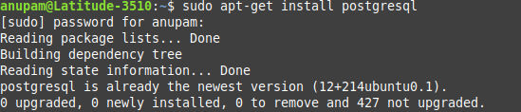

## Start the PostgreSQL service and check the status

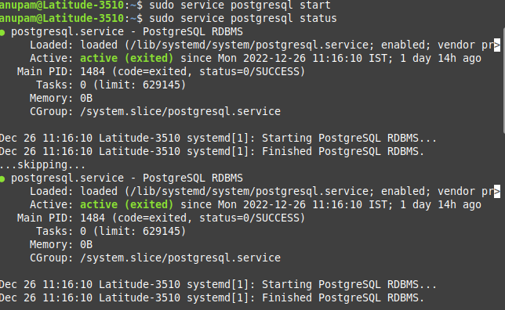

1. Start using postgres

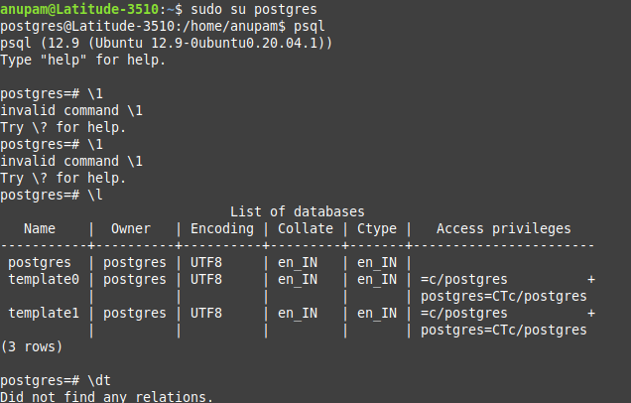

# Conclusion

If our installation is correct, we will have PostgreSQL prompt postgres=# as shown above. Hence Installation of PostgreSQL completed successfully.

## **Experiment 2**

**AIM:** Consider Schema: Student (student_name, enrollment_no, marks, area, branch)

Write SQL queries on

a. DDL (eg create, alter, drop, rename, truncate),

b. DML (eg. Insert, update, delete etc.),

c. DCL (eg. Grant, revoke etc.)

d. Built-in Functions (eg. Sum, min, max, avg, count, lower, upper, trim, len etc.)

e. Indexes and views: Create and Drop

### THEORY:

**DDL (Data Definition Language):**

DDL or Data Definition Languageactually consists of the SQL commands that can be used to define the database schema. It simply deals with descriptions of the database schema and is used to create and modify the structure of database objects in the database.DDL is a set of SQL commands used to create, modify, and delete database structures but not data. These commands are normally not used by a general user, who should be accessing the database via an application.

List of DDL commands:

CREATE: This command is used to create the database or its objects (like table, index, function, views, store procedure, and triggers).

DROP: This command is used to delete objects from the database.

ALTER: This is used to alter the structure of the database.

TRUNCATE: This is used to remove all records from a table, including all spaces allocated for the records are removed.

COMMENT: This is used to add comments to the data dictionary.

RENAME: This is used to rename an object existing in the database.

**DML(Data Manipulation Language):**

The SQL commands that deals with the manipulation of data present in the database belong to DML or Data Manipulation Language and this includes most of the SQL statements. It is the component of the SQL statement that controls access to data and to the database. Basically, DCL statements are grouped with DML statements.

List of DML commands:

INSERT: It is used to insert data into a table.

UPDATE: It is used to update existing data within a table.

DELETE: It is used to delete records from a database table.

LOCK: Table control concurrency.

CALL: Call a PL/SQL or JAVA subprogram.

EXPLAIN PLAN: It describes the access path to data.

**DCL (Data Control Language):**

DCL includes commands such as GRANT and REVOKE which mainly deal with the rights, permissions, and other controls of the database system.

List of DCL commands:

GRANT: This command gives users access privileges to the database.

REVOKE: This command withdraws the user’s access privileges given by using the GRANT command.

**Indexes**

Indexes are special lookup tables that the database search engine can use to speed up data retrieval. Simply put, an index is a pointer to data in a table. An index in a database is very similar to an index in the back of a book.

For example, if you want to reference all pages in a book that discusses a certain topic, you first refer to the index, which lists all the topics alphabetically and is then referred to one or more specific page numbers.

An index helps to speed up SELECT queries and WHERE clauses, but it slows down data input, with the UPDATE and the INSERT statements. Indexes can be created or dropped with no effect on the data.

Creating an index involves the CREATE INDEX statement, which allows you to name the index, to specify the table and which column or columns to index, and indicate whether the index is in an ascending or descending order.

Indexes can also be unique, like the UNIQUE constraint, in that the index prevents duplicate entries in the column or combination of columns on which there is an index.

**Views**

A view is nothing more than a SQL statement that is stored in the database with an associated name. A view is actually a composition of a table in the form of a predefined SQL query.

A view can contain all rows of a table or select rows from a table. A view can be created from one or many tables which depends on the written SQL query to create a view.

Views, which are a type of virtual table allow users to do the following −

Structure data in a way that users or classes of users find natural or intuitive.

Restrict access to the data in such a way that a user can see and (sometimes) modify exactly what they need and no more.

Summarize data from various tables which can be used to generate reports.

**Implementation :**

**Create Command**

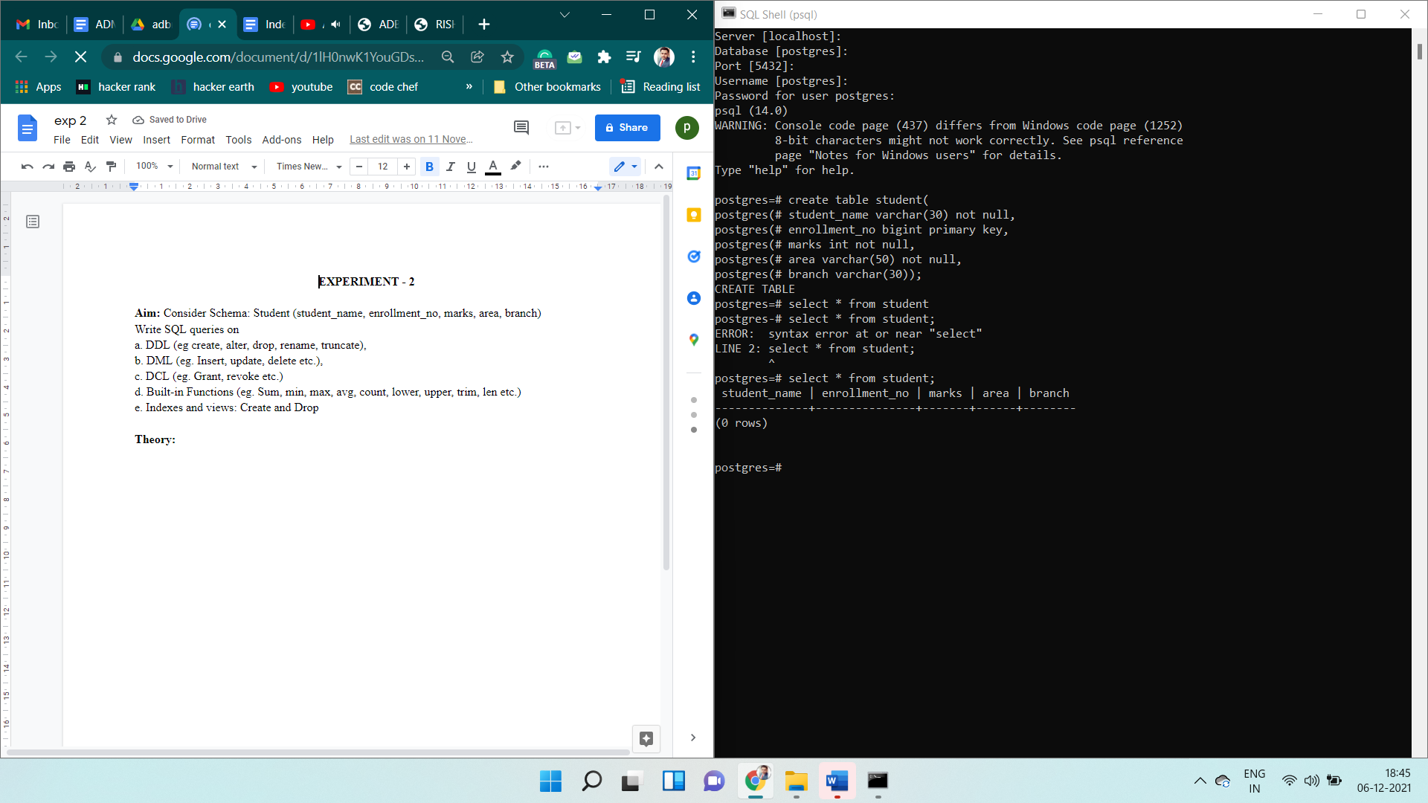



**Alter Command**

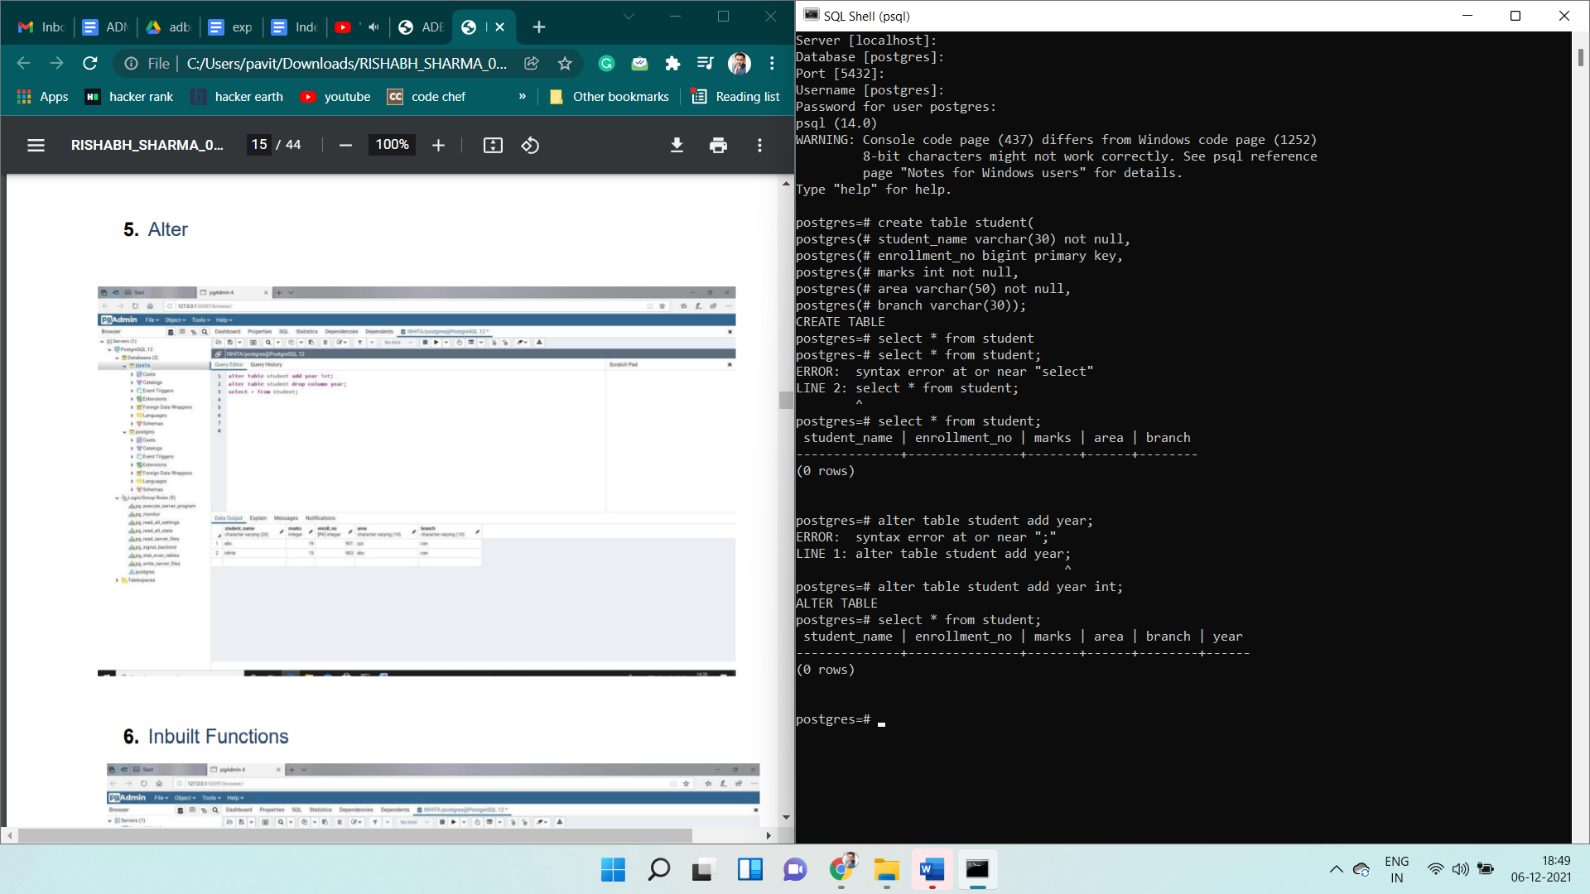

**Drop Command**

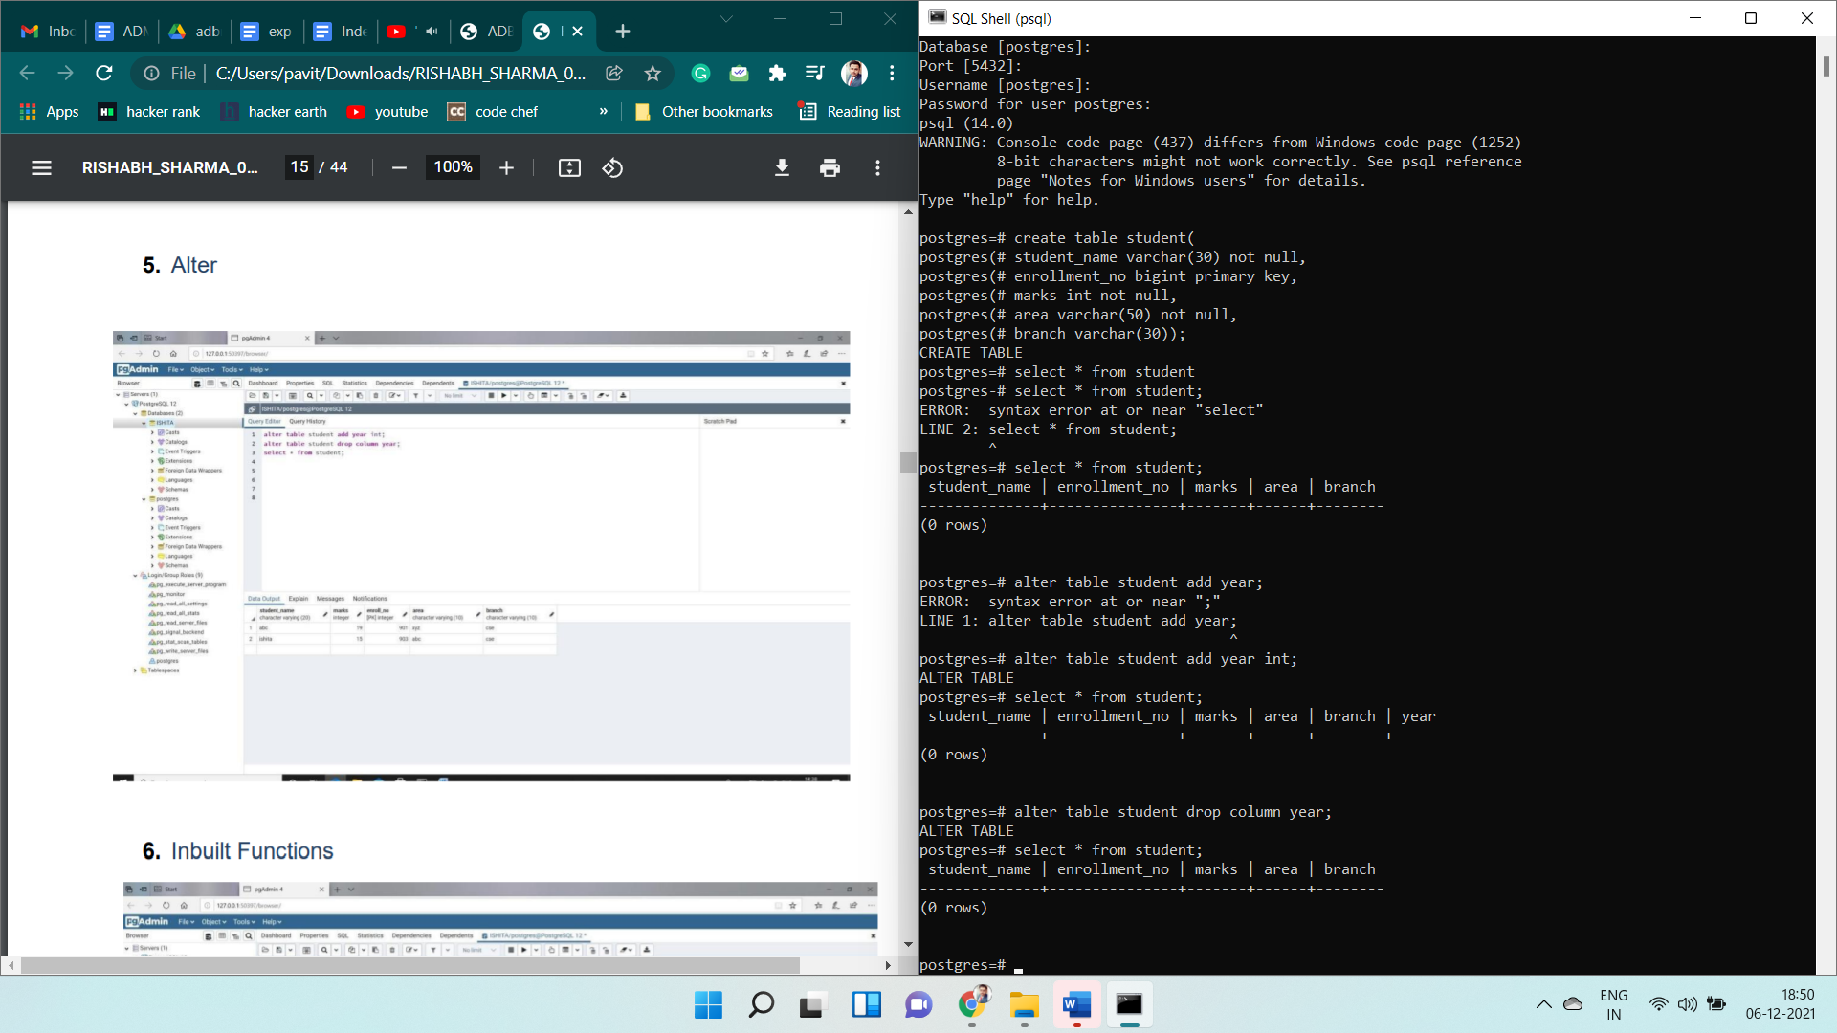

**Rename Command**

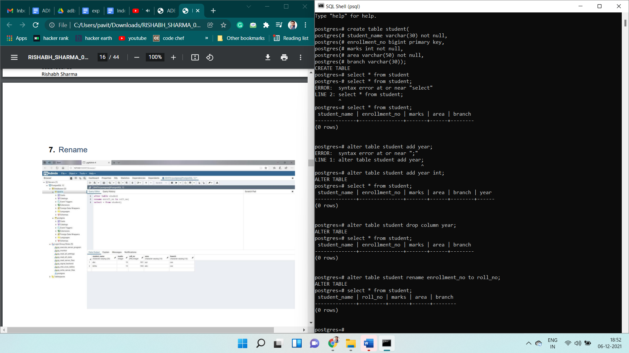

**Truncate Command**

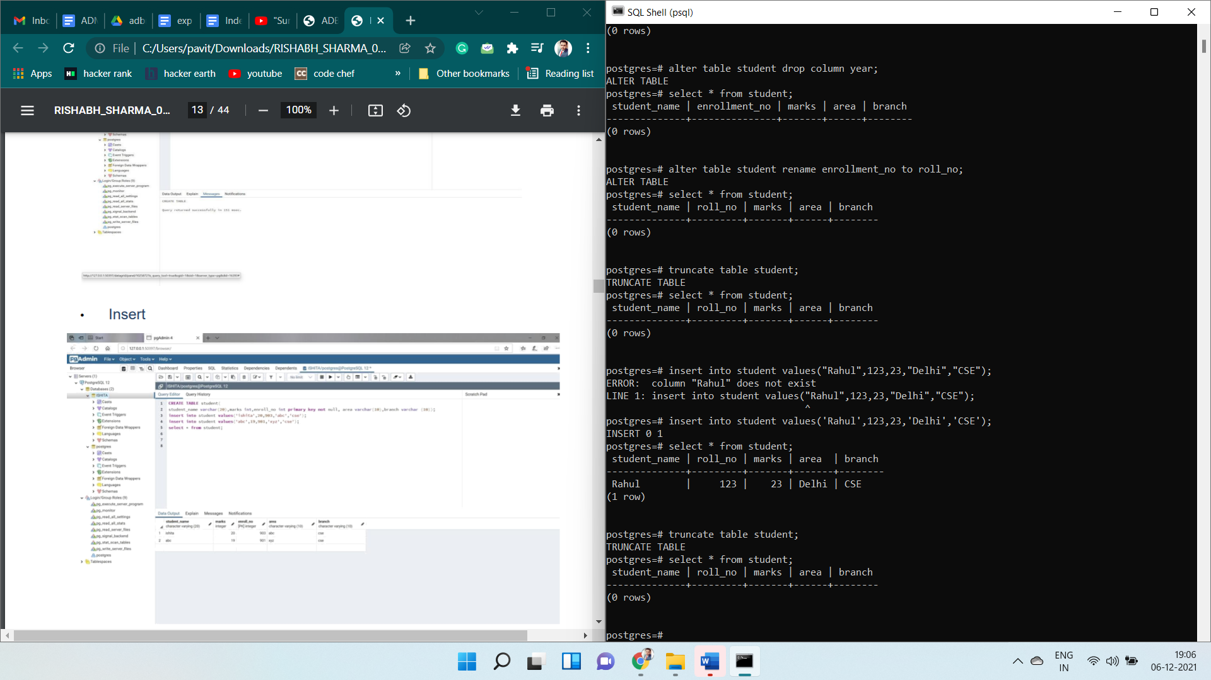

**Insert Command**

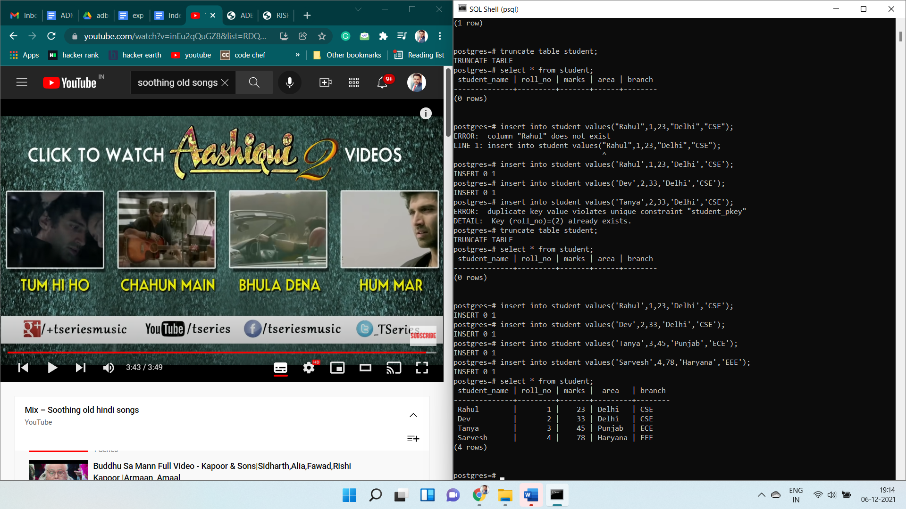

**Update Command**

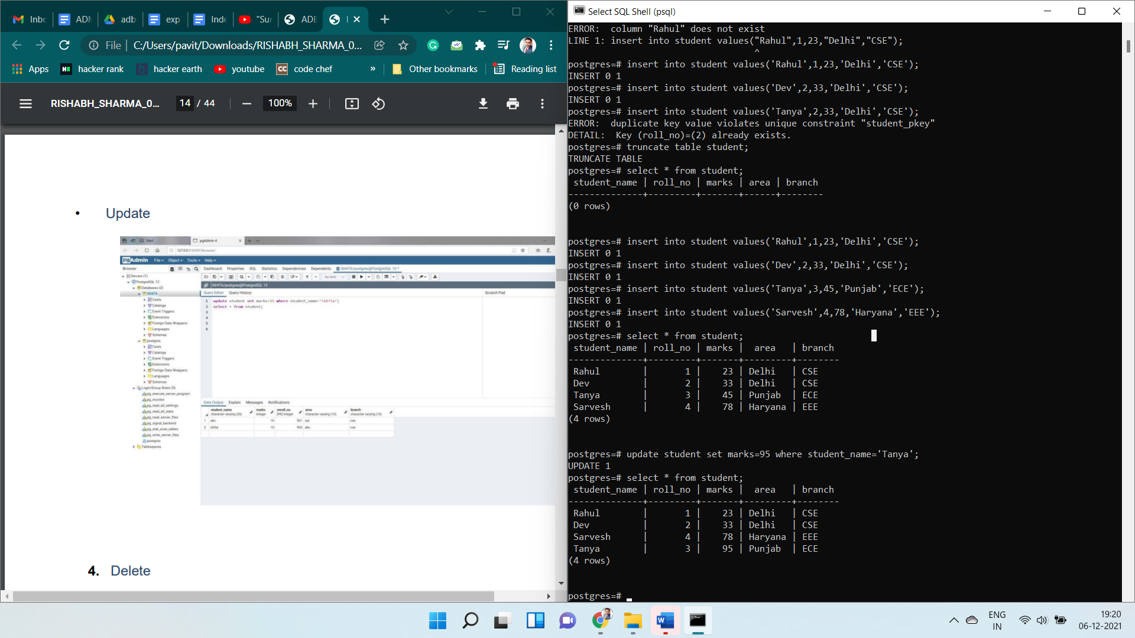

**Delete Command**

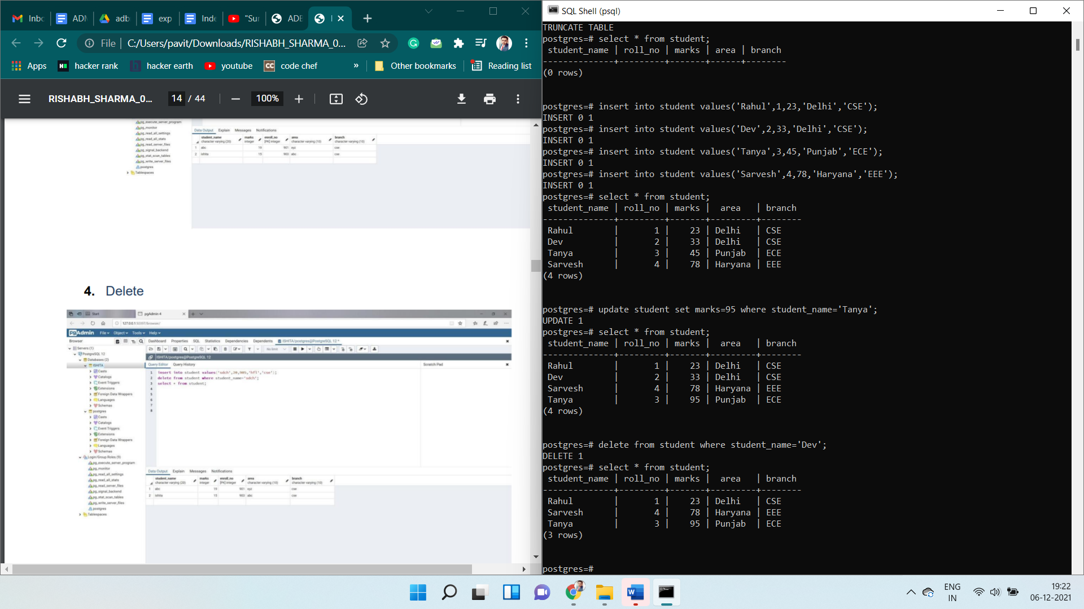

**Grant & Revoke Command**

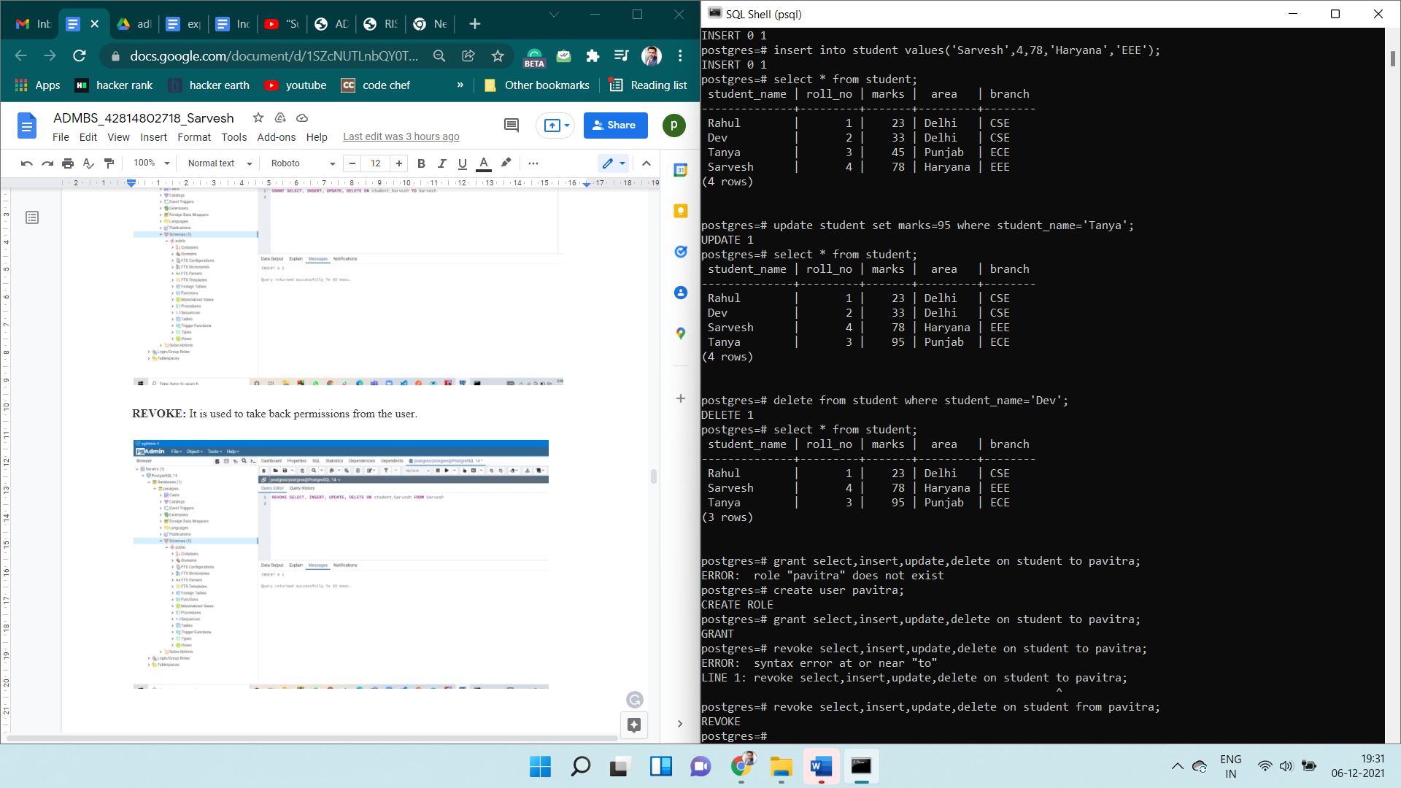

**Sum Function**

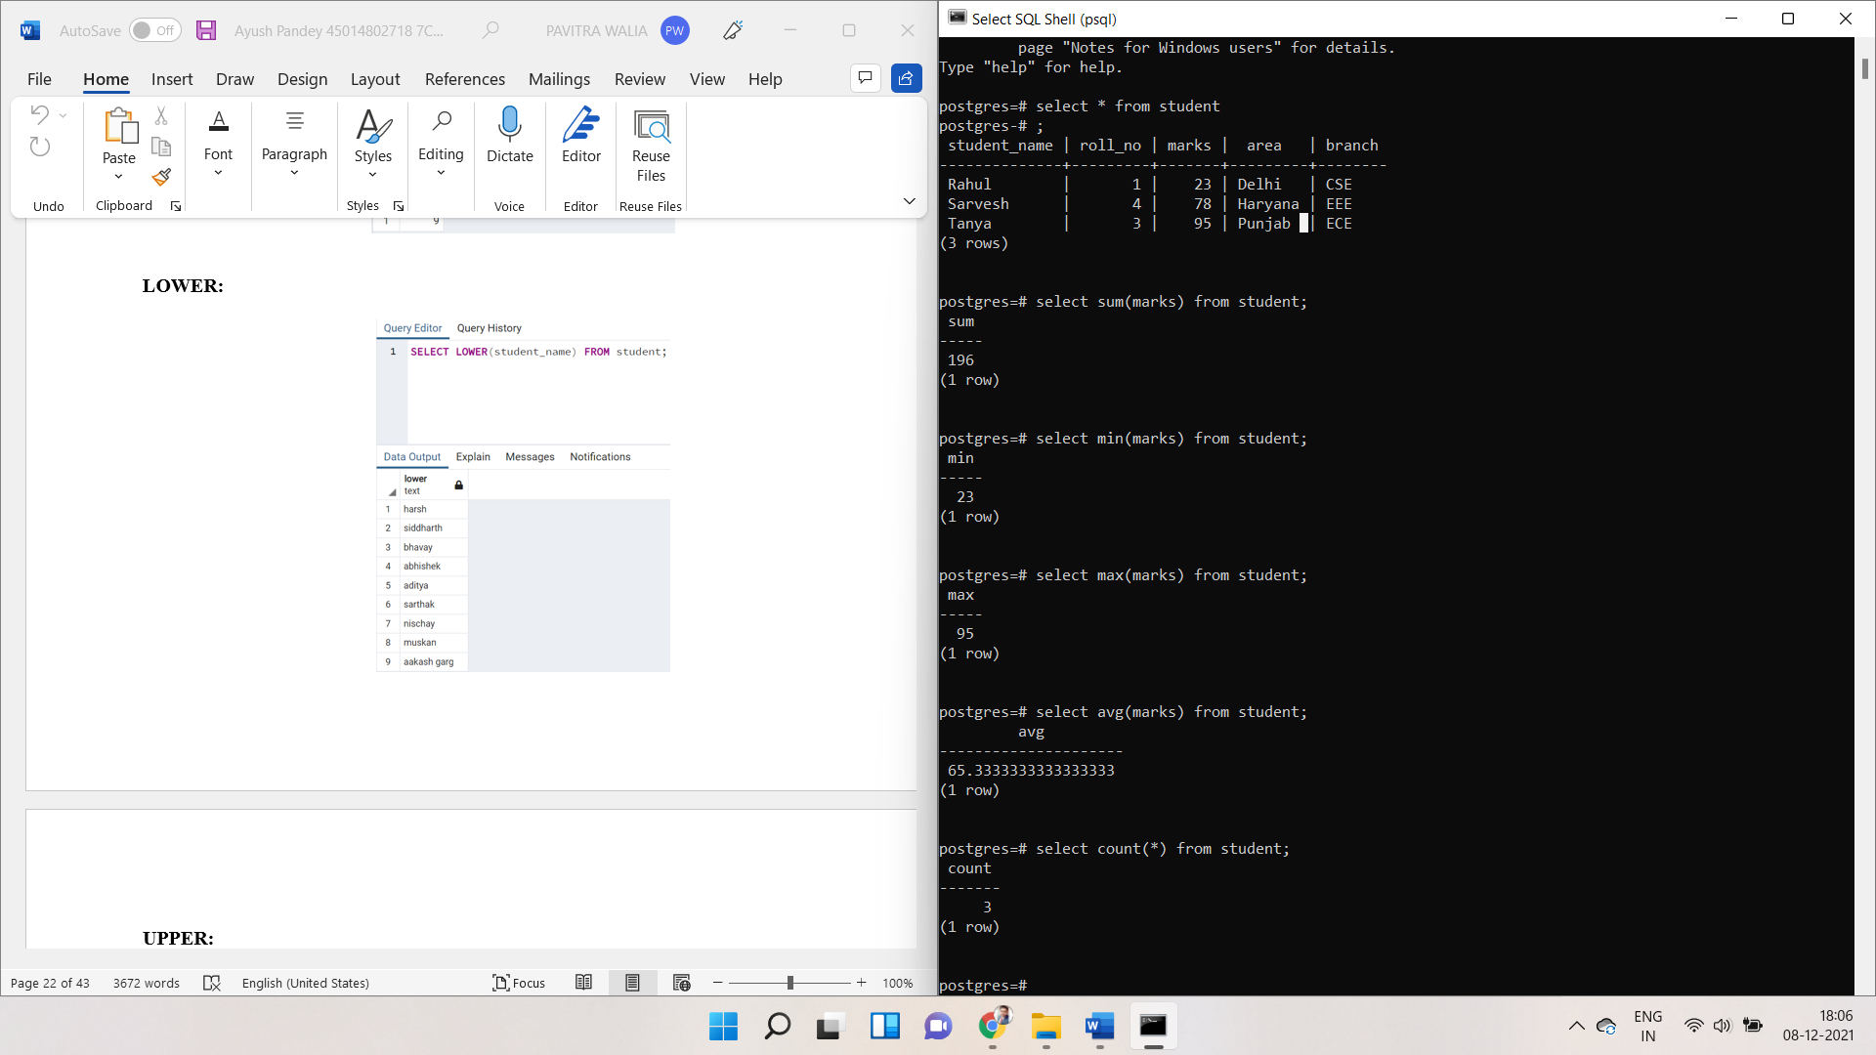

**Min Function**



**Max Function**



**Avg Function**



**Count Function**



**Lower Function**

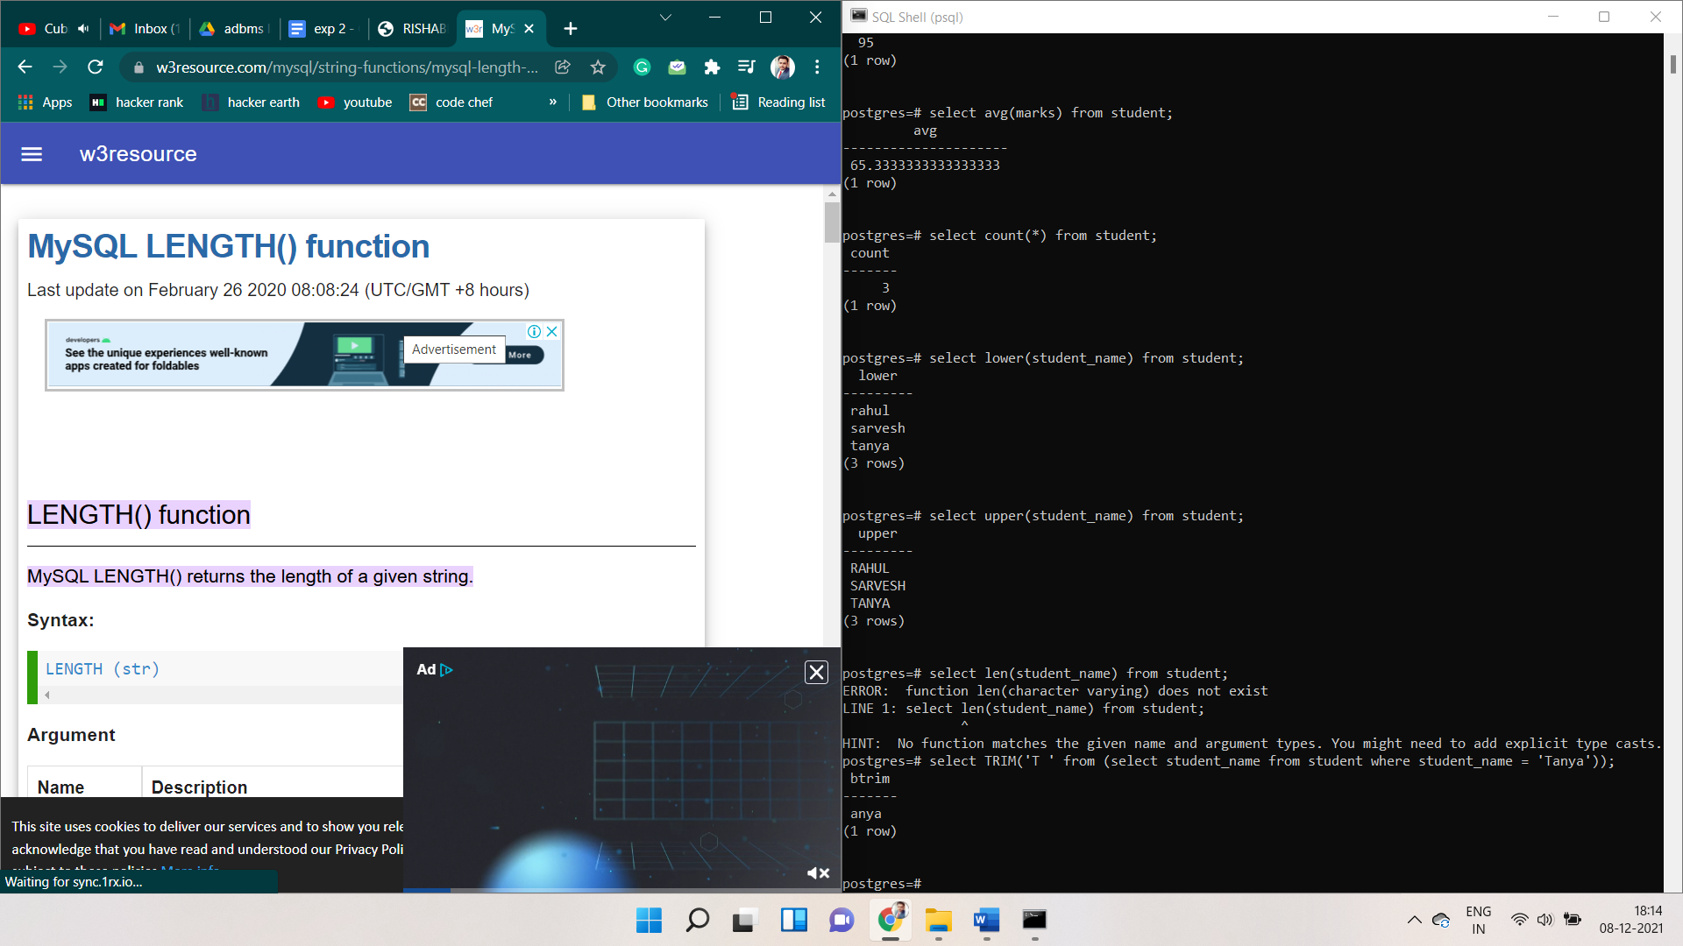

**Upper Function**



**Trim Function**



**Indexes**

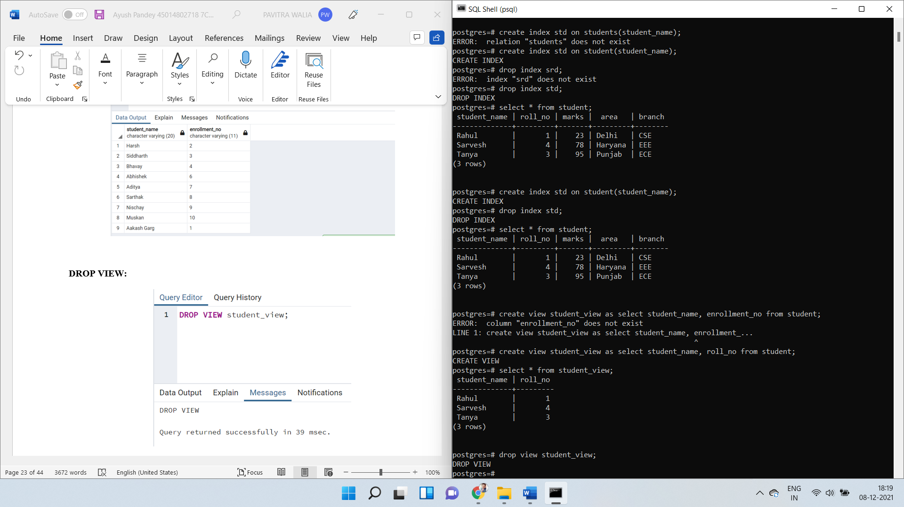

**Views**



**EXPERIMENT - 3**

**Aim:** Write SQL queries on Nested queries and Join.

**Theory:**

In nested queries, a query is written inside a query. The result of the inner query is used in the execution of the outer query.

Independent Nested Queries: In independent nested queries, query execution starts from innermost queries to outermost queries.

The execution of the inner query is independent of the outer query, but the result of the inner query is used in the execution of the outer query. Various operators like IN, NOT IN, ANY, ALL etc are used in writing independent nested queries.

Co-related Nested Queries: In co-related nested queries, the output of the inner query depends on the row which is being currently executed in the outer query.

**Implementation :**

**Nested Queries**

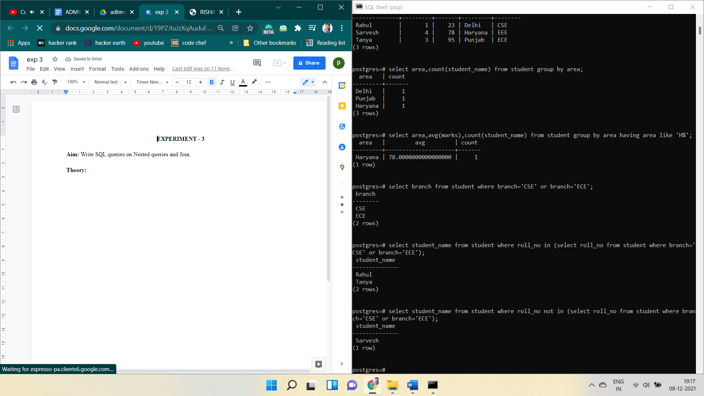

**Cross Join**

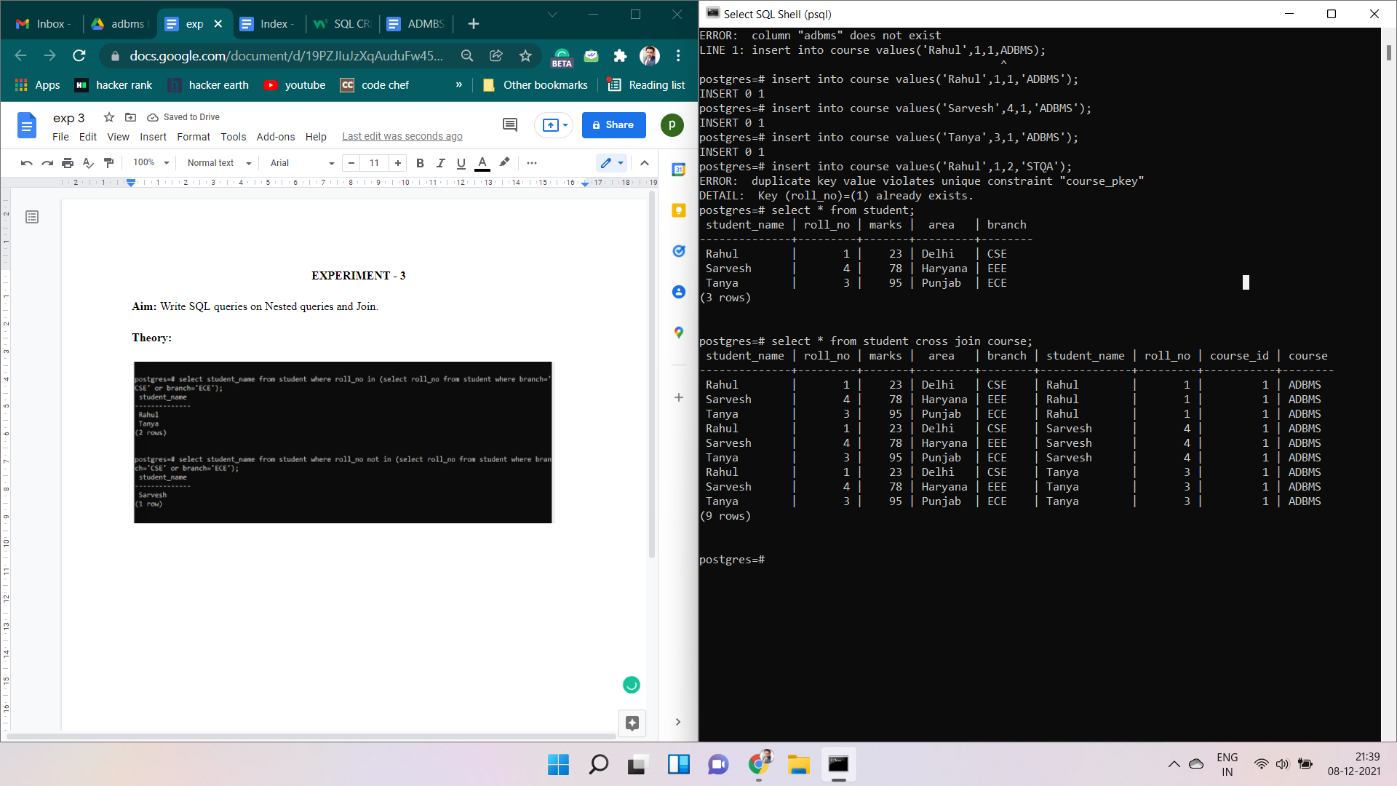

**Inner Join**

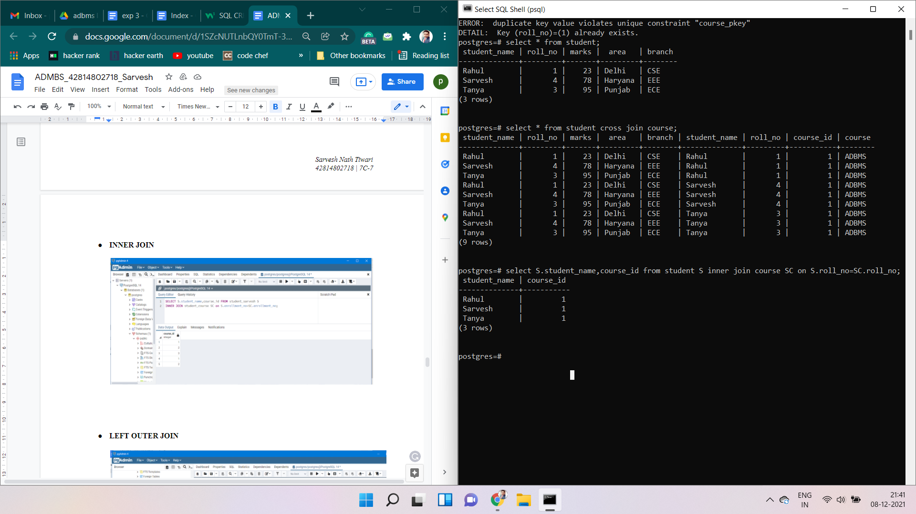

**Left Outer Join**

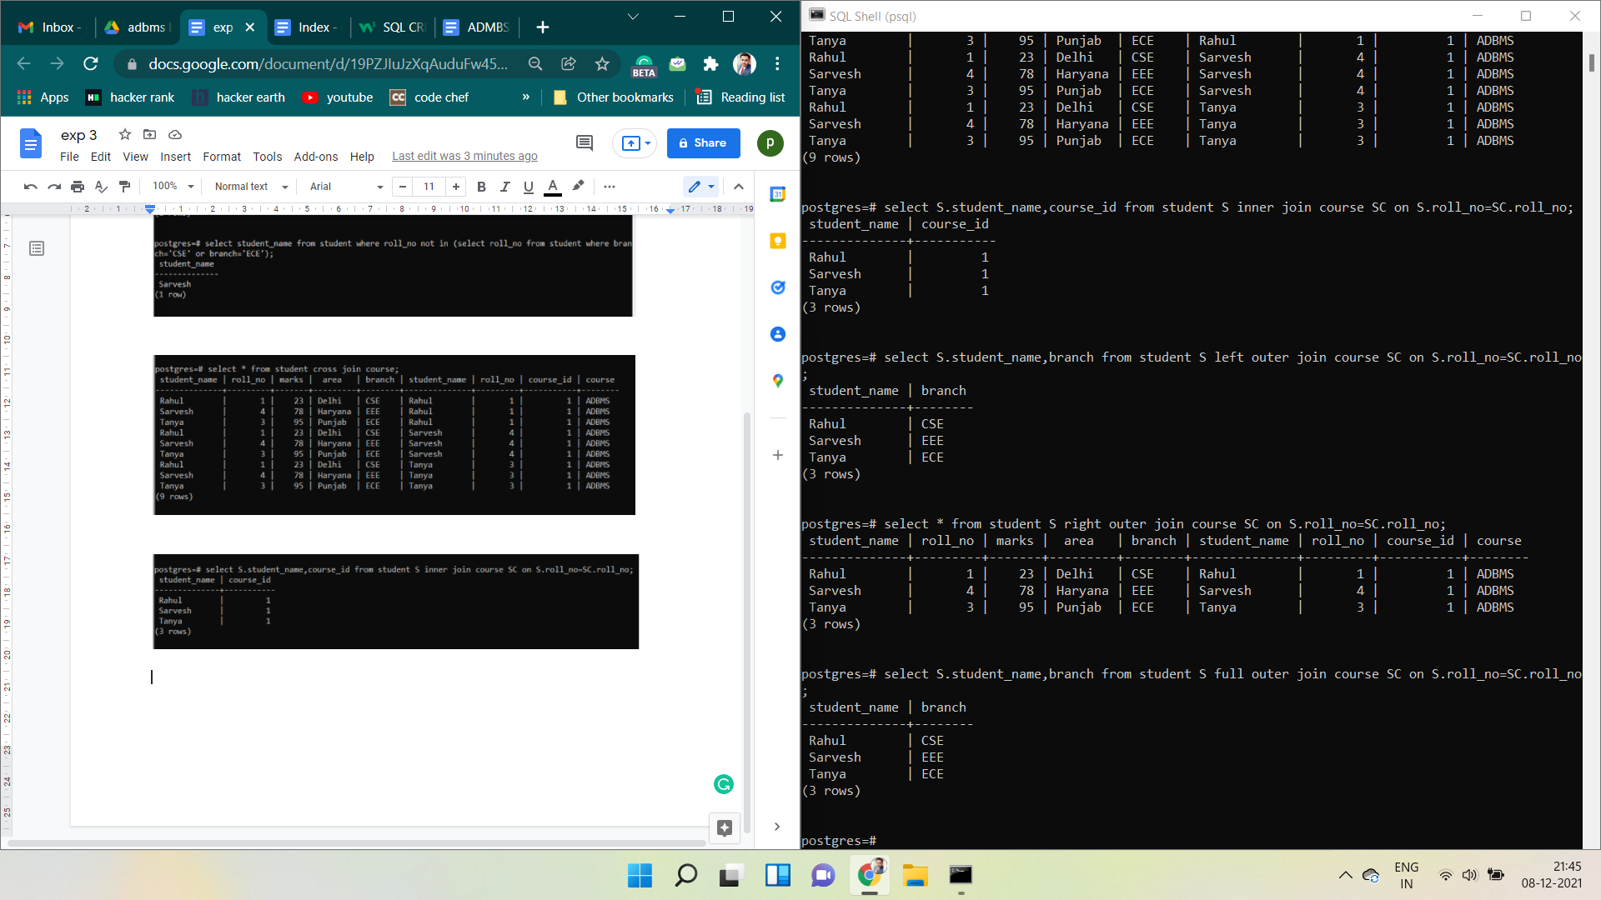

**Right Outer Join**



**Full Outer Join**



**EXPERIMENT - 4**

**Aim:** PL/SQL

a. write a program to calculate total students enrolled areawise.

b. Write a program to calculate average marks obtained by students residing in the area that starts with "D"

**Theory:**

The PL/SQL Function is very similar to PL/SQL Procedure. The main difference between a procedure and a function is, a function must always return a value, and on the other hand, a procedure may or may not return a value. Except this, all the other things of the PL/SQL procedure are true for PL/SQL function too.

Syntax to create a function:

CREATE [OR REPLACE] FUNCTION function_name

[(parameter_name type [, ...])]

// this statement is must for functions

RETURN return_datatype

{IS | AS}

BEGIN

// program code

[EXCEPTION

exception_section;

END [function_name];

Advantages:

We can make a single call to the database to run a block of statements thus it improves the performance against running SQL multiple times. This will reduce the number of calls between the database and the application.

We can divide the overall work into small modules which becomes quite manageable also enhancing the readability of the code.

It promotes reusability.

It is secure since the code stays inside the database thus hiding internal database details from the application(user). The user only makes a call to the PL/SQL functions. Hence security and data hiding is ensured.

**Implementation :**

1. **Calculate total students enrolled area wise.**

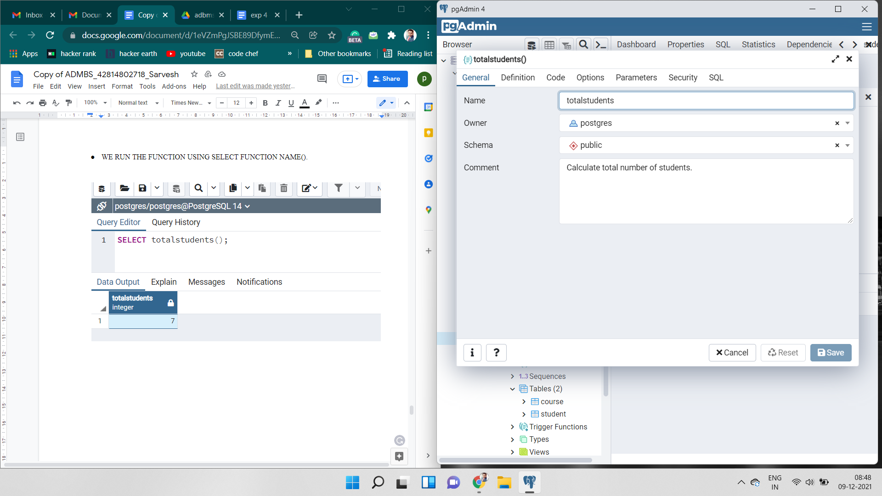 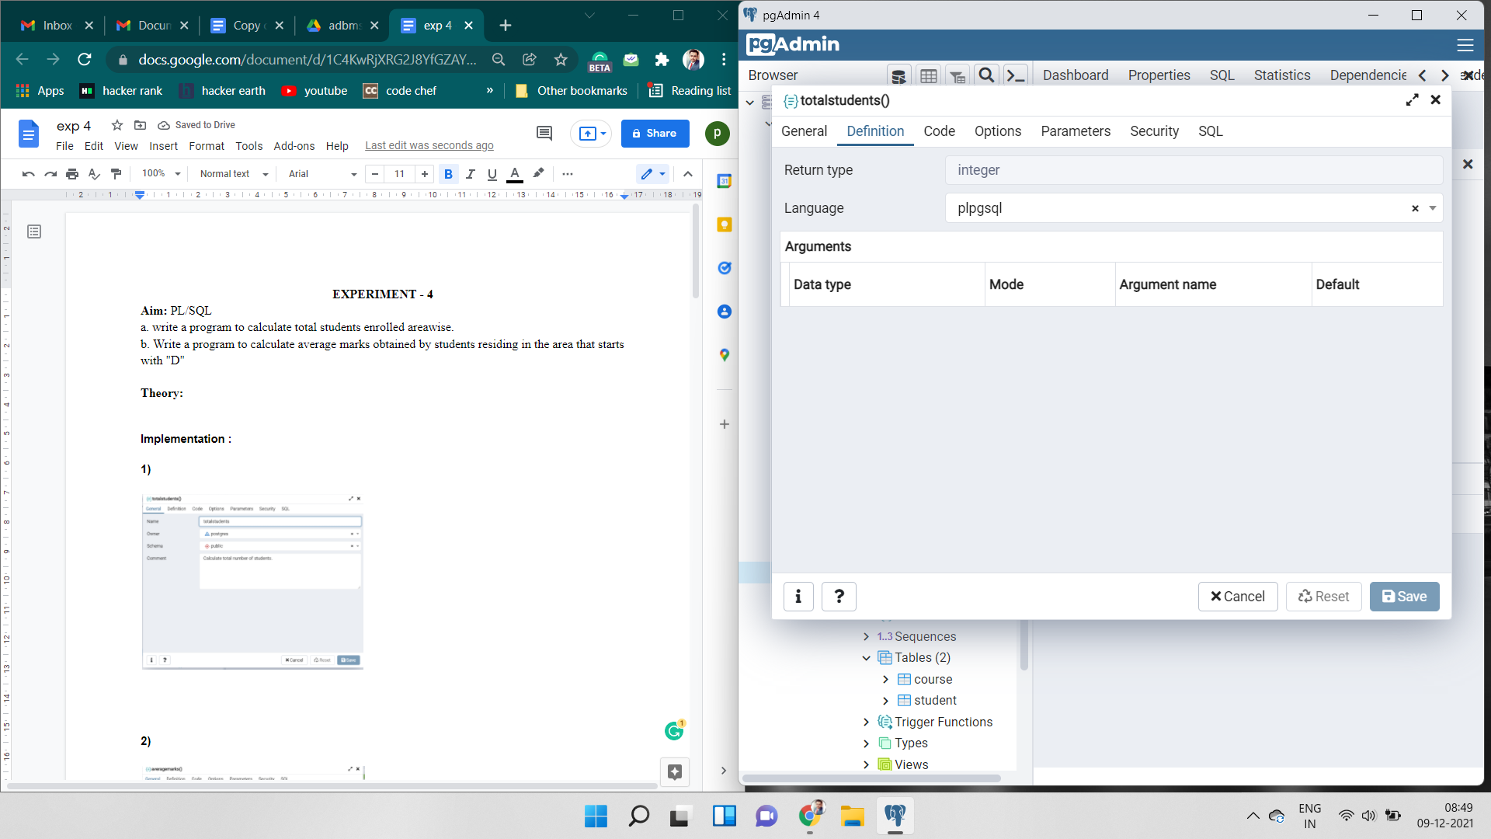

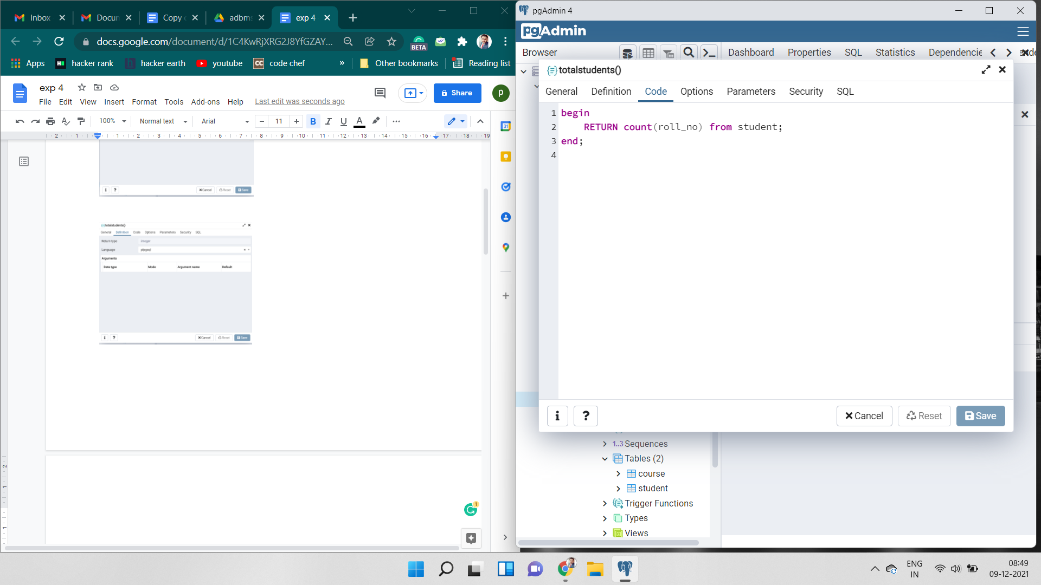 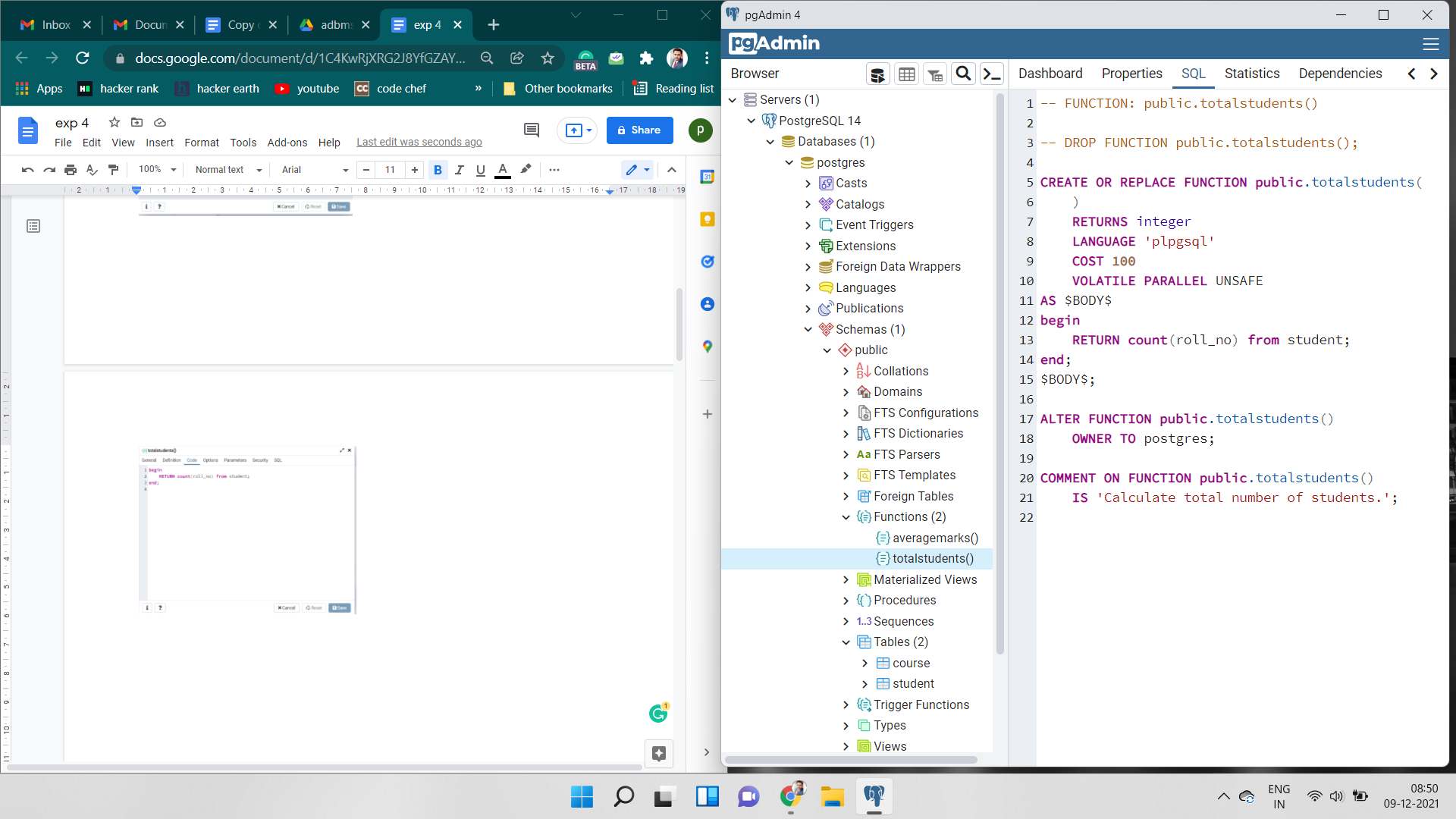

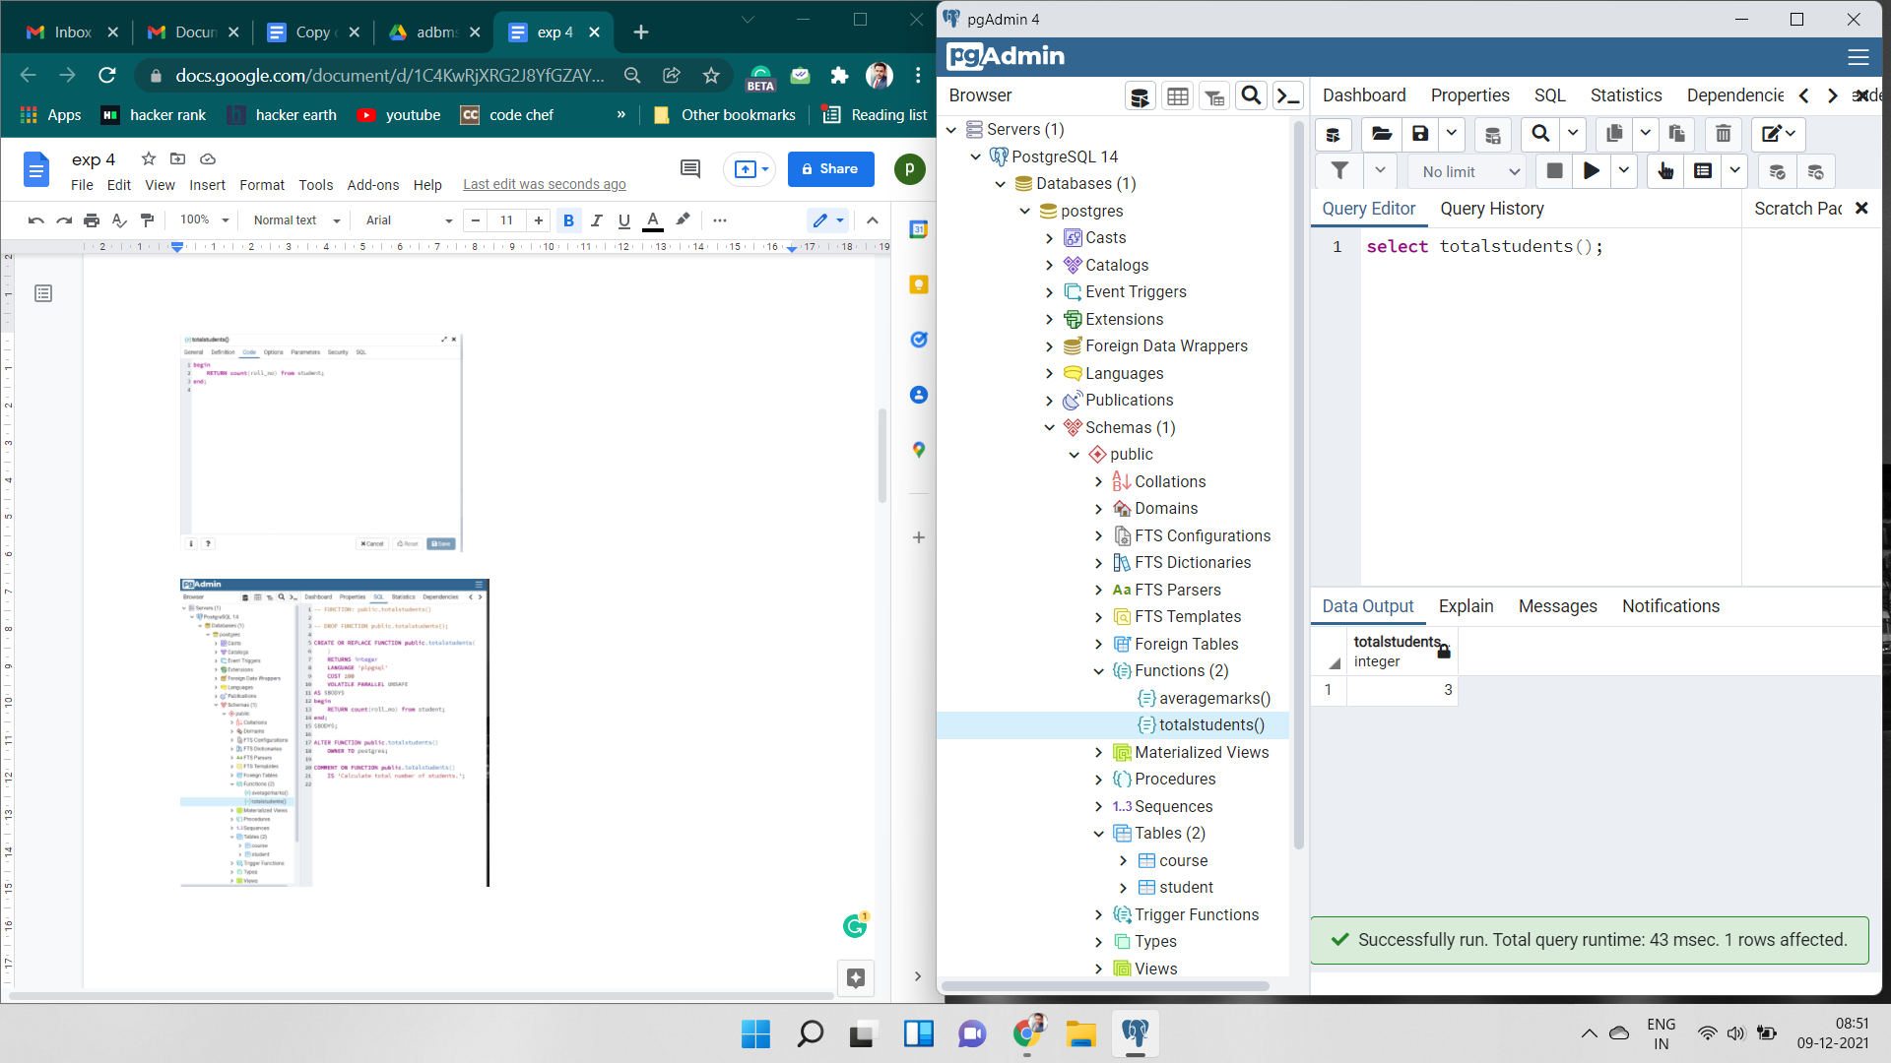 

1. **Calculate average marks obtained by students residing in the area that starts with "D"**

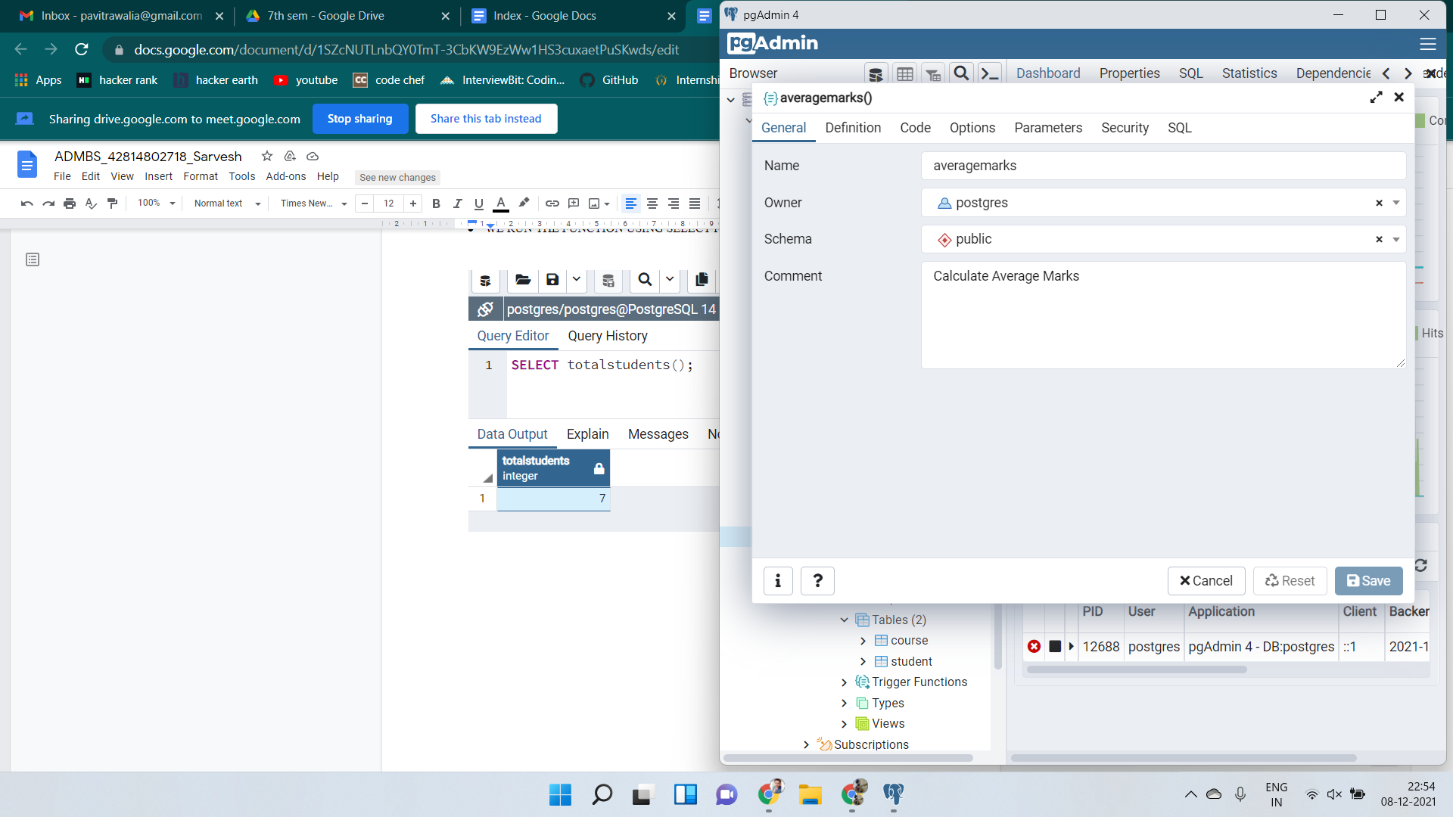 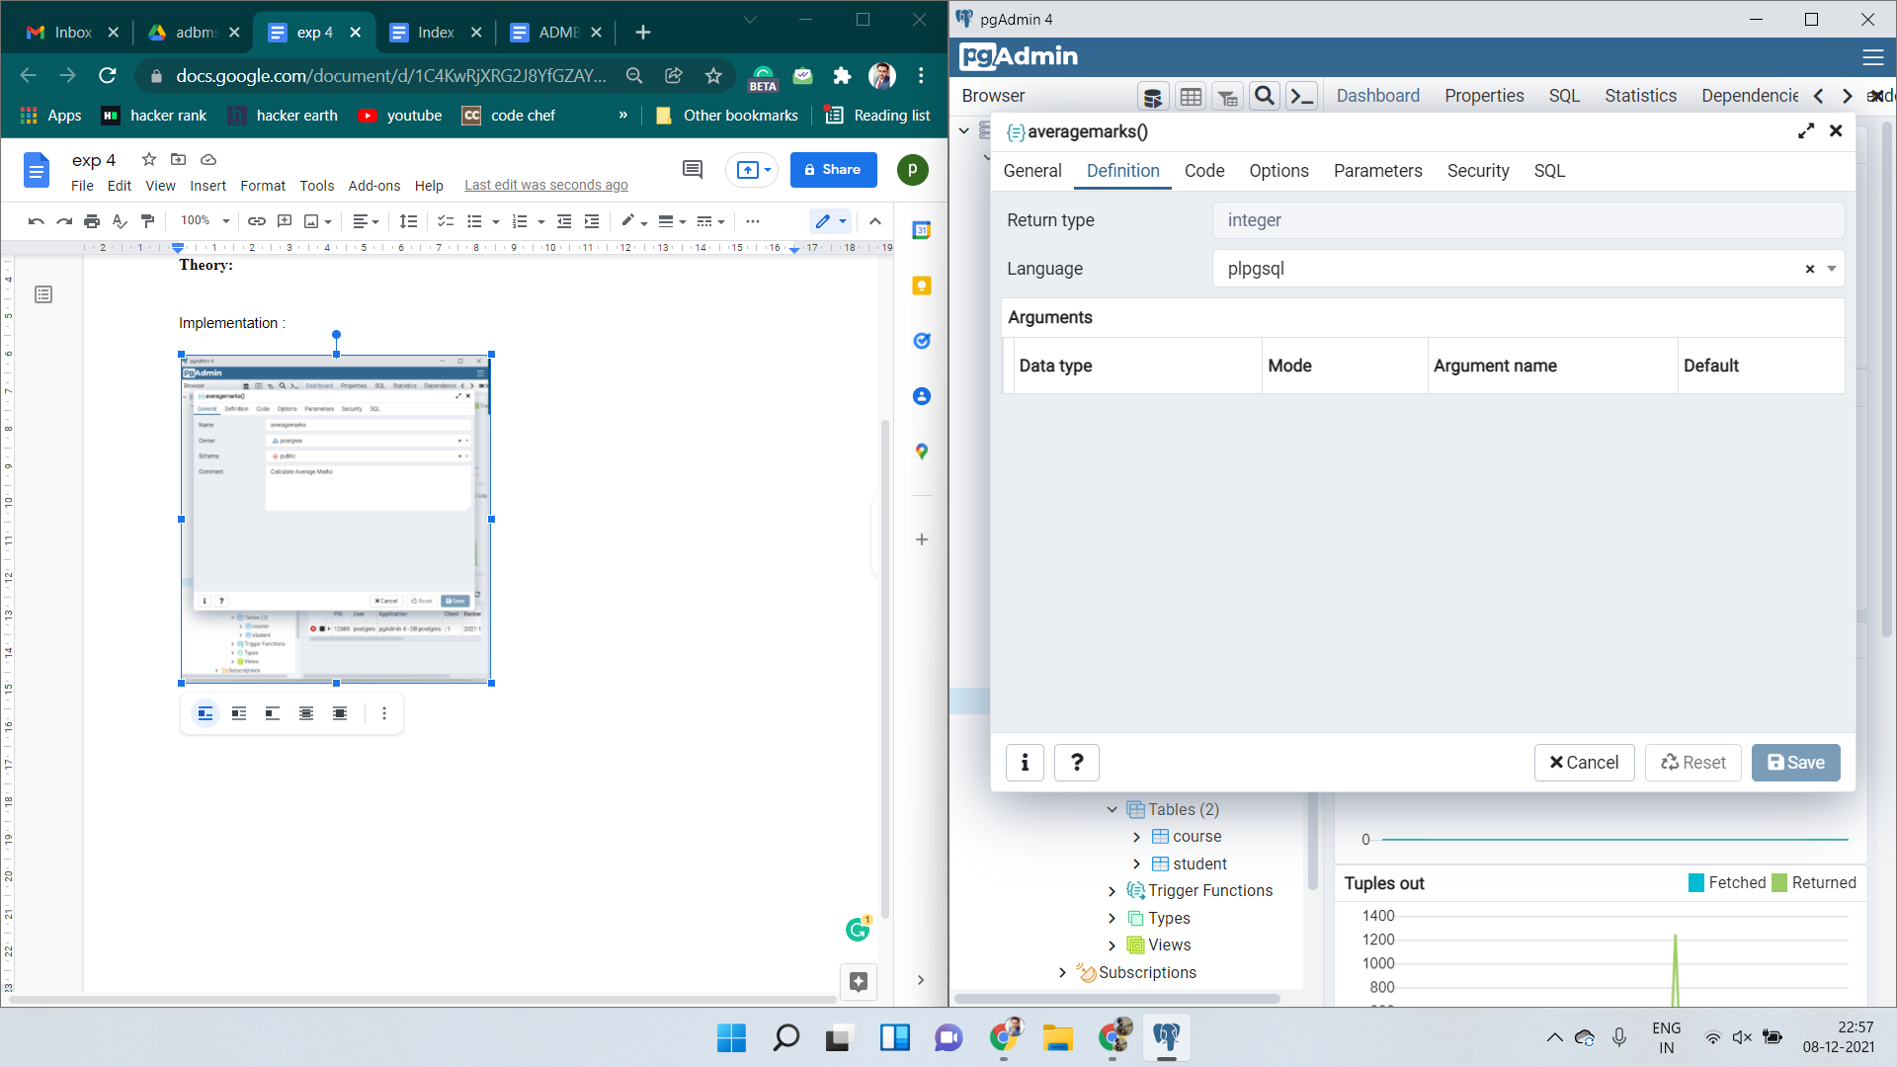

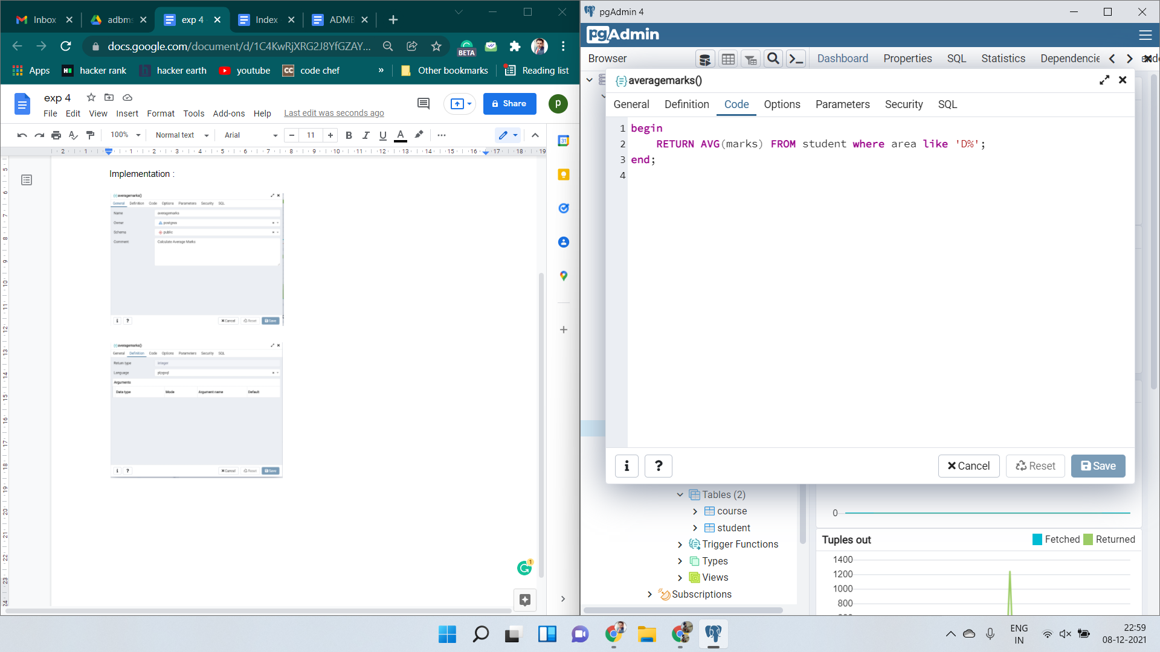 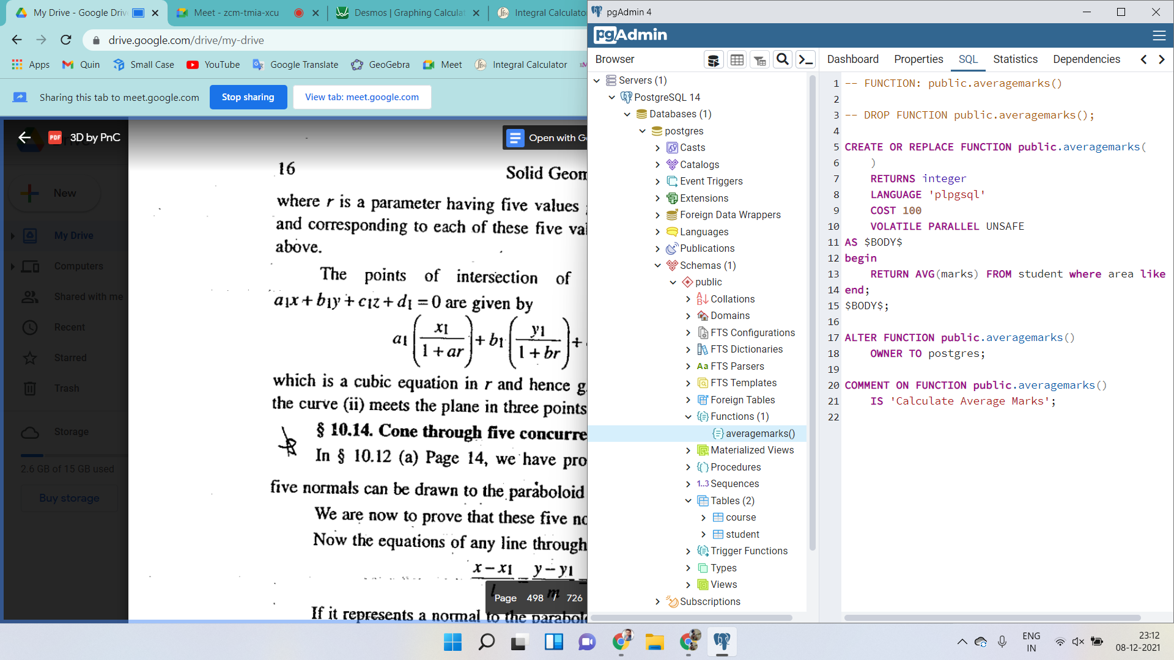

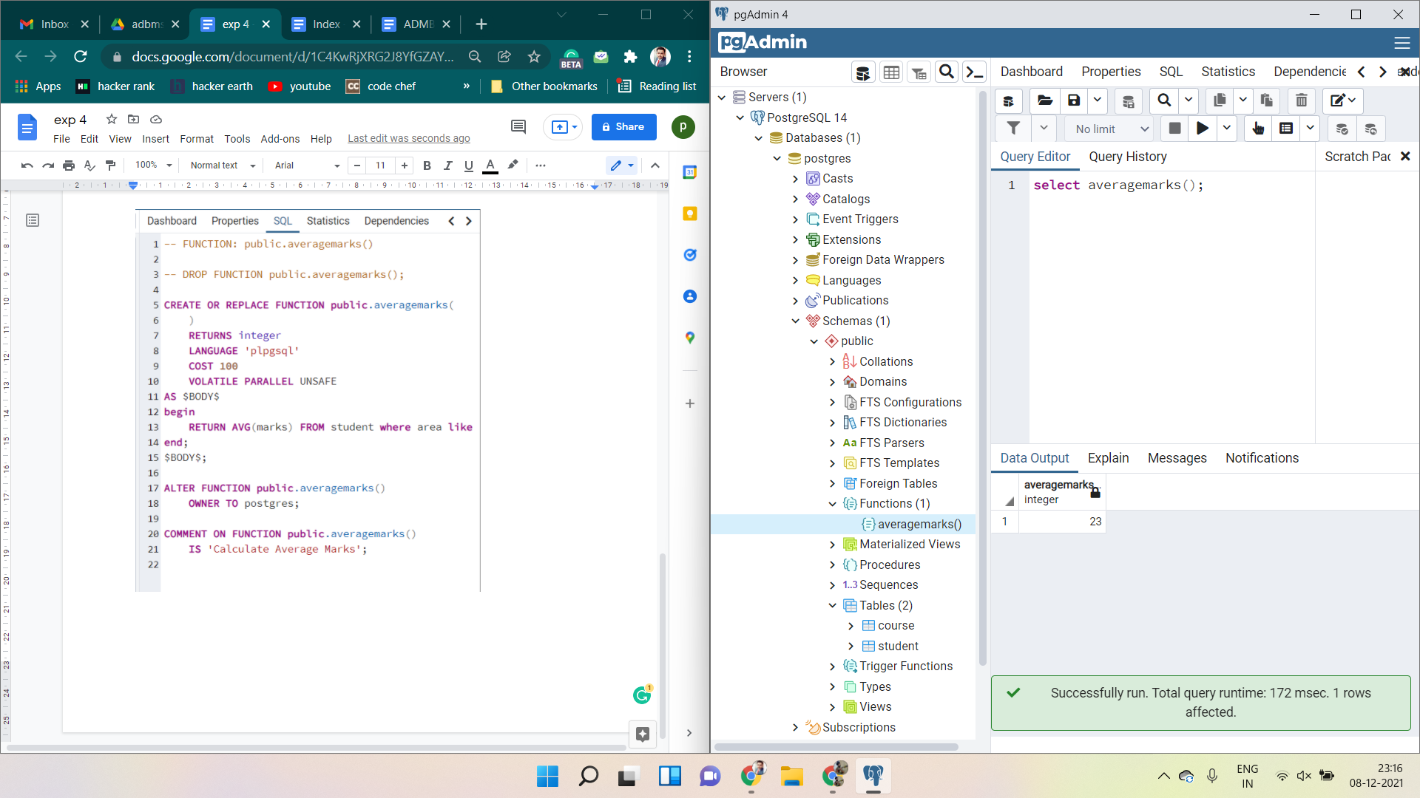 

**EXPERIMENT - 5**

**Aim:** Cursor

Write the cursor to increase the marks of students by 10%.

**Theory:**

**Cursors**

To execute SQL statements, a work area is used by the Oracle engine for its internal processing and storing the information. This work area is private to SQL’s operations. The ‘Cursor’ is the PL/SQL construct that allows the user to name the work area and access the stored information in it.

**Use of Cursor**

* The major function of a cursor is to retrieve data, one row at a time, from a result set, unlike the SQL commands which operate on all the rows in the result set at one time. Cursors are used when the user needs to update records in a singleton fashion or in a row by row manner, in a database table.
* The Data that is stored in the Cursor is called the Active Data Set. Oracle DBMS has another predefined area in the main memory Set, within which the cursors are opened. Hence the size of the cursor is limited by the size of this pre-defined area.

**Cursor Actions**

* Declare Cursor: A cursor is declared by defining the SQL statement that returns a result set.
* Open: A Cursor is opened and populated by executing the SQL statement defined by the cursor.
* Fetch: When the cursor is opened, rows can be fetched from the cursor one by one or in a block to perform data manipulation.
* Close: After data manipulation, close the cursor explicitly.
* Deallocate: Finally, delete the cursor definition and release all the system resources associated with the cursor.

**Types of Cursors**

Cursors are classified depending on the circumstances in which they are opened.

Implicit Cursor: If the Oracle engine opened a cursor for its internal processing it is known as an Implicit Cursor. It is created “automatically” for the user by Oracle when a query is executed and its simpler to code.

Explicit Cursor: A Cursor can also be opened for processing data through a PL/SQL block, on-demand. Such a user-defined cursor is known as an Explicit Cursor.

**Implementation :**

**Table Student before the cursor is executed**

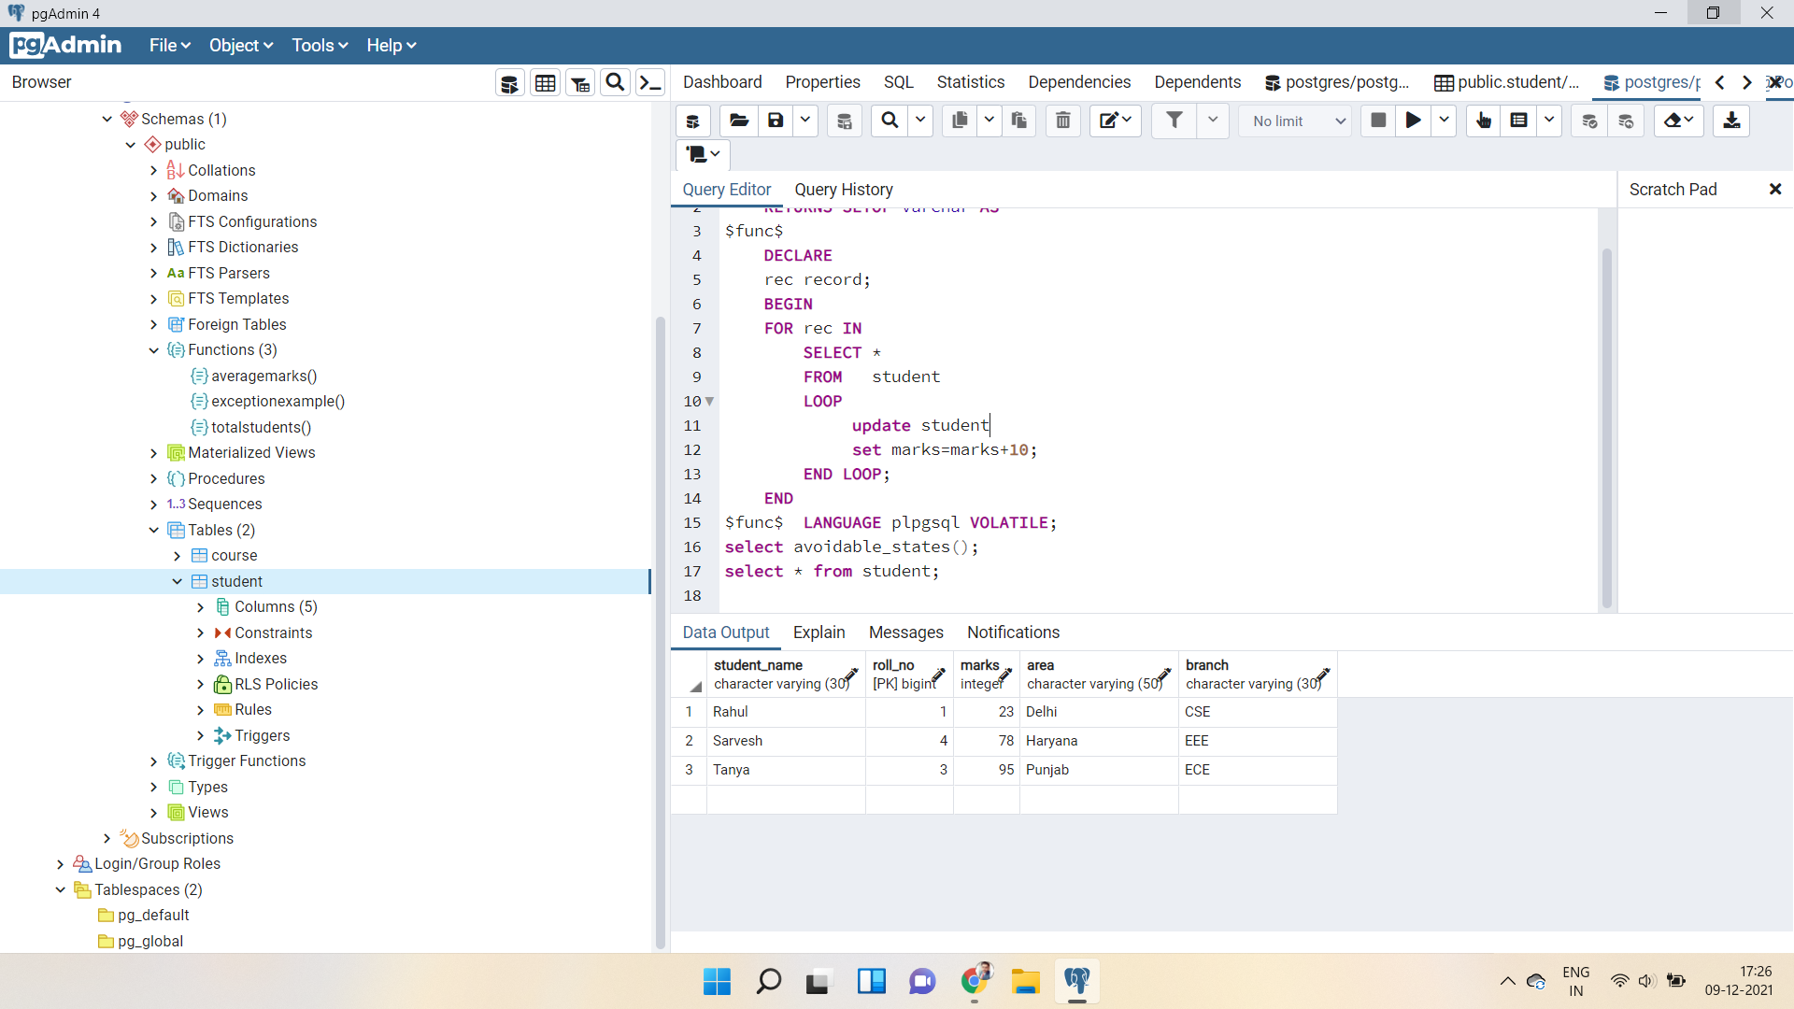

**Table Student after the cursor is executed**

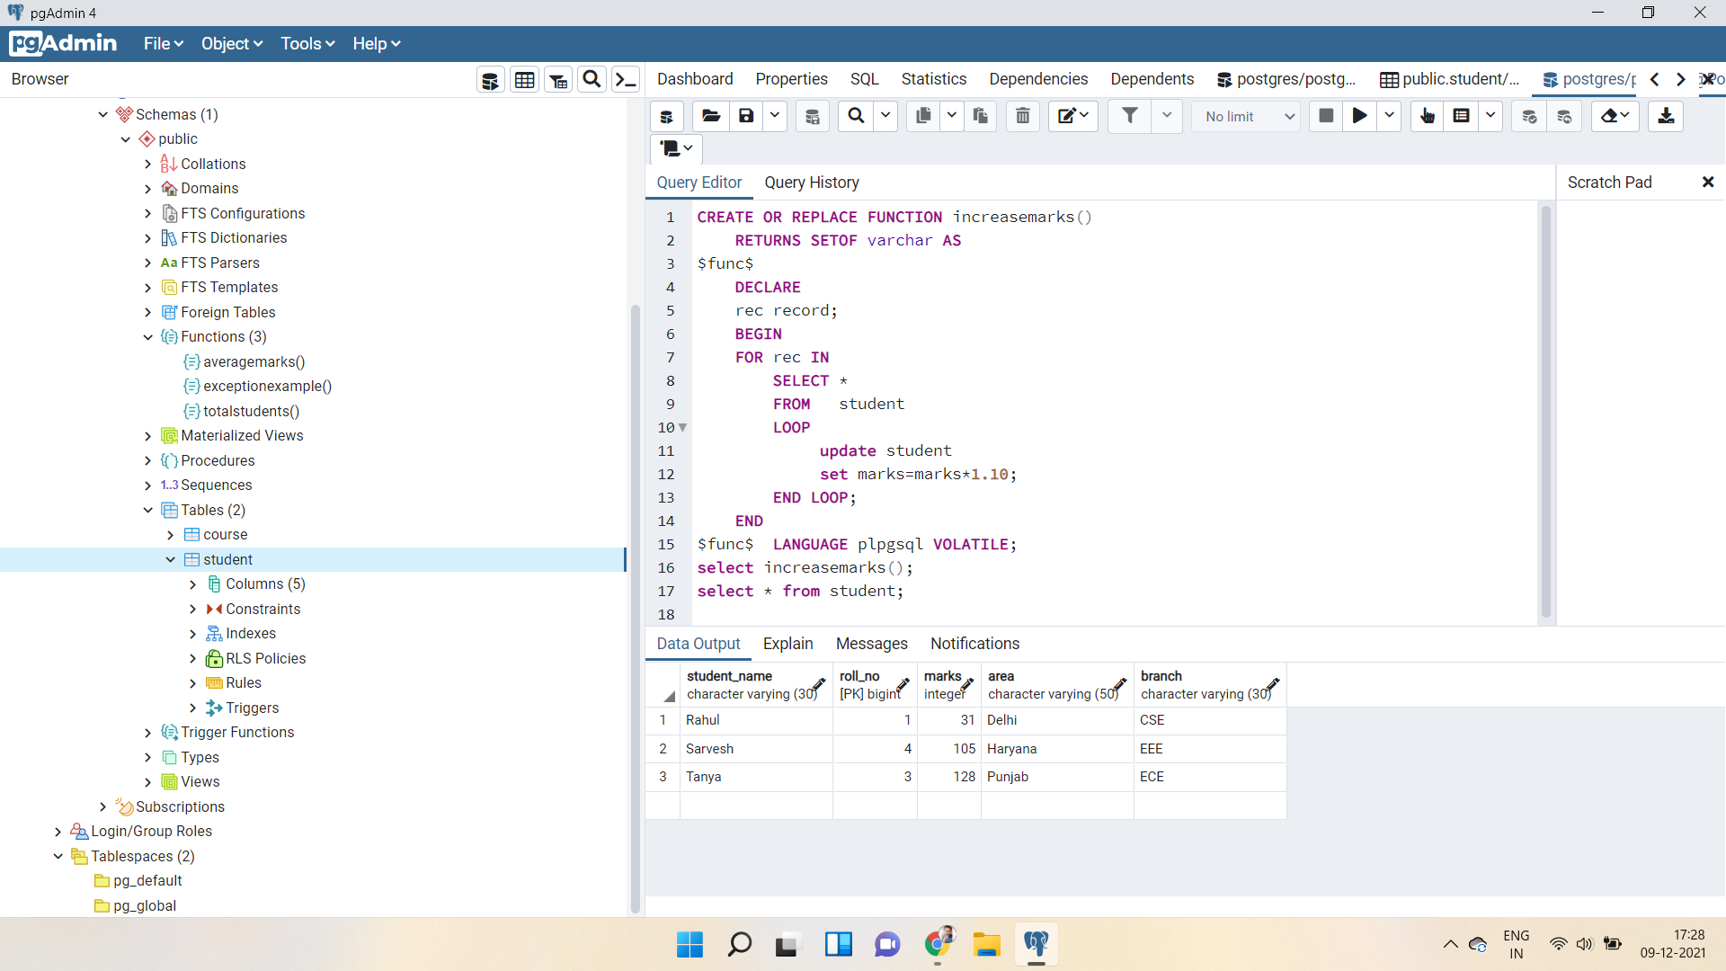

**EXPERIMENT - 6**

**Aim:** Exception Handling

Write a program to create exceptions if enrollment no. is not issued to students by the university and raise the exception explicitly by using the raise command.

**Theory:**

An exception is an error that disrupts the normal flow of program instructions. PL/SQL provides us with the exception block which raises the exception thus helping the programmer to find out the fault and resolve it.

There are two types of exceptions defined in PL/SQL

* System defined exceptions:

These exceptions are predefined in PL/SQL which get raised WHEN certain database rule is violated.

* User-defined exceptions:

This type of user can create their own exceptions according to the need and to raise these exceptions explicitly raise command is used.

**Raising Exceptions**

Exceptions are raised by the database server automatically whenever there is an internal database error, but exceptions can be raised explicitly by the programmer by using the command RAISE. Following is the simple syntax for raising an exception −

DECLARE

exception_name EXCEPTION;

BEGIN

IF condition THEN

RAISE exception_name;

END IF;

EXCEPTION

WHEN exception_name THEN

statement;

END;

**Implementation :**

**Execution of instruction without any error.**

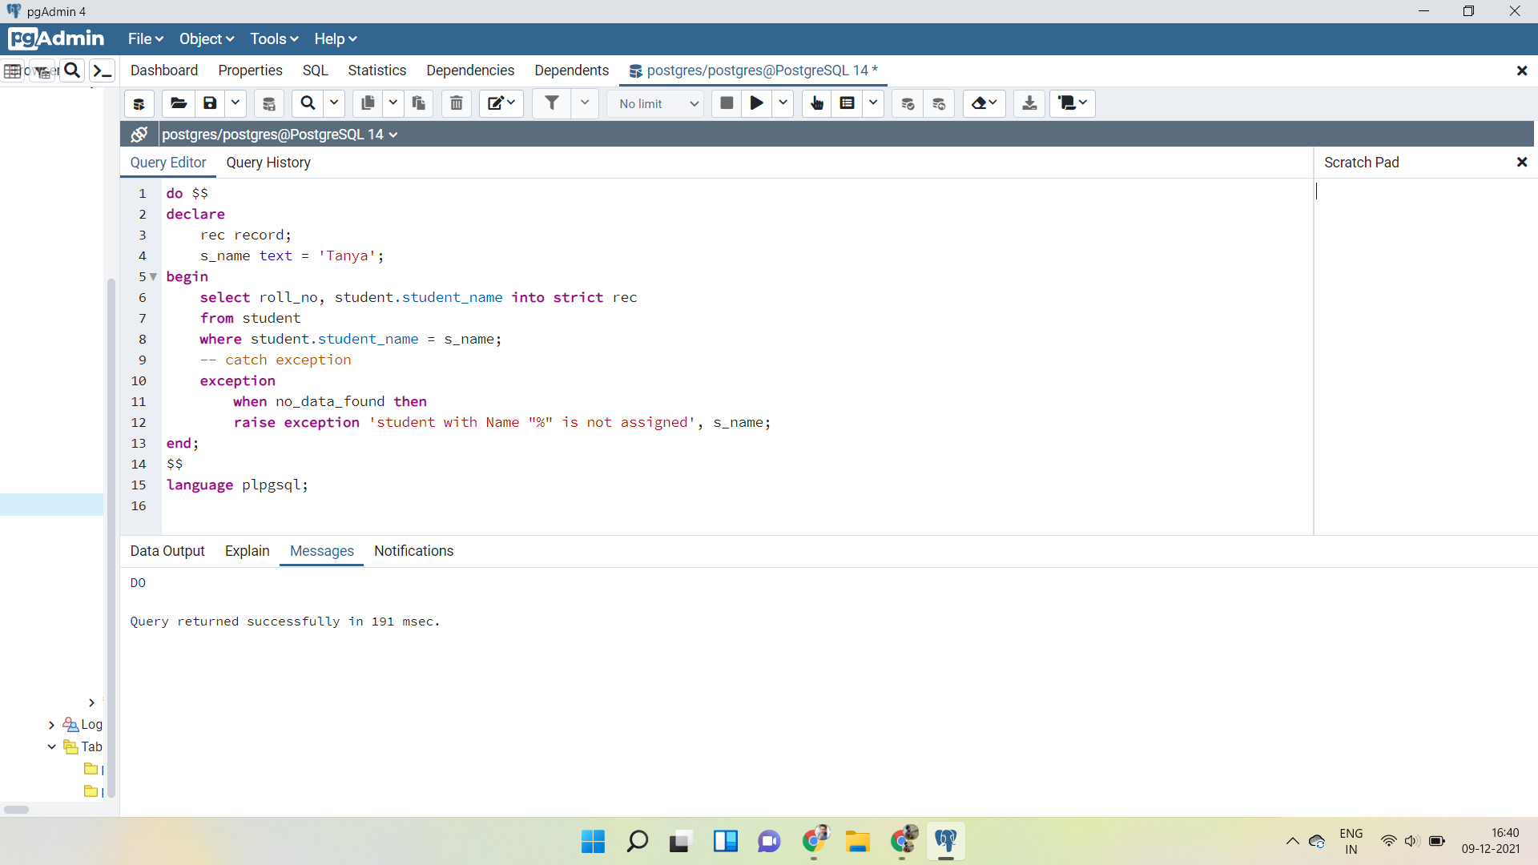

**Execution of instruction with an exception.**

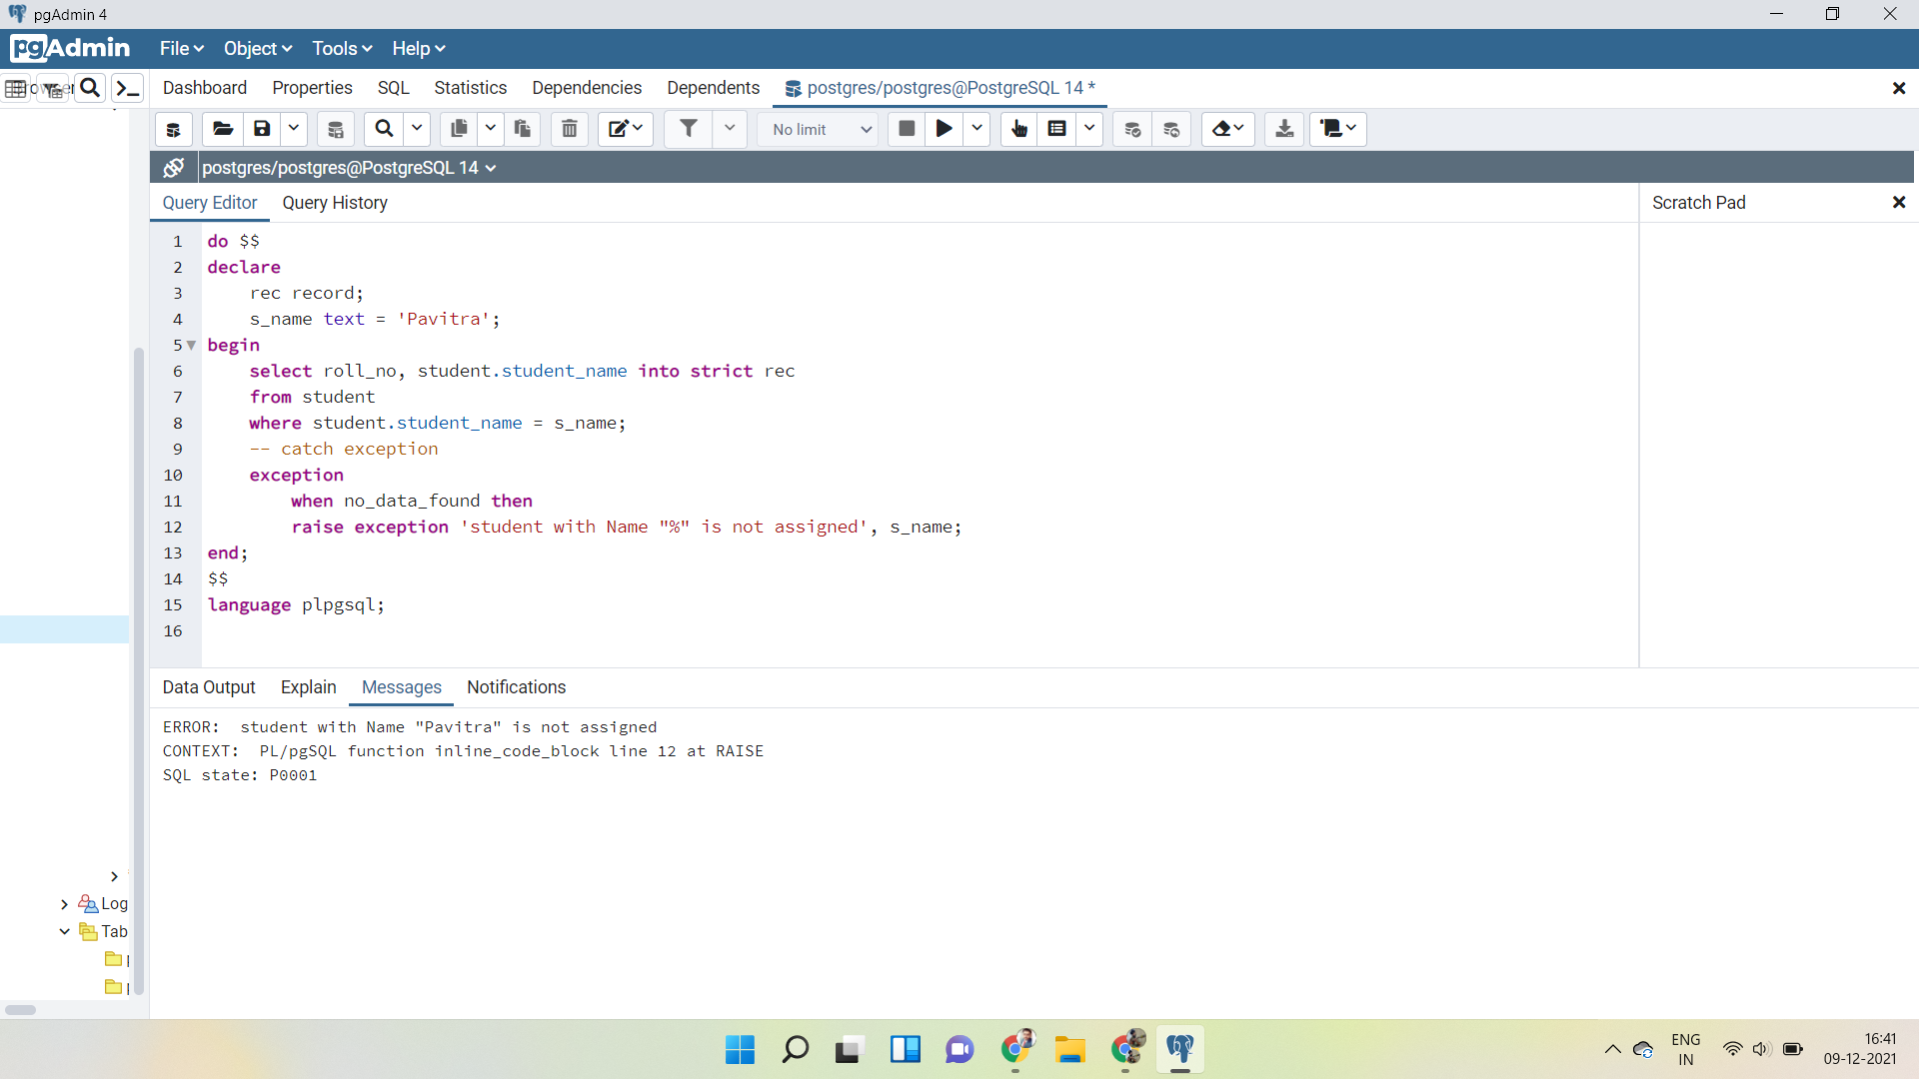

**EXPERIMENT - 7**

**Aim:** Procedure & Function

a. Write the procedure to get the average marks of students for branch “CSE”.

b. Write a function that accepts branches and returns the total no. of students of the branch.

**Theory:**

**PL/SQL Procedure**

The PL/SQL stored procedure or simply a procedure is a PL/SQL block that performs one or more specific tasks. It is just like procedures in other programming languages.

The procedure contains a header and a body.

* Header: The header contains the name of the procedure and the parameters or variables passed to the procedure.
* Body: The body contains a declaration section, execution section and exception section similar to a general PL/SQL block.

*Syntax for creating procedure:*

CREATE [OR REPLACE] PROCEDURE procedure_name

[ (parameter [,parameter]) ]

IS

[declaration_section]

BEGIN

executable_section

[EXCEPTION

exception_section]

END [procedure_name];

**PL/SQL Function**

The PL/SQL Function is very similar to PL/SQL Procedure. The main difference between a procedure and a function is, a function must always return a value, and on the other hand, a procedure may or may not return a value. Except this, all the other things of the PL/SQL procedure are true for PL/SQL function too.

*Syntax to create a function:*

CREATE [OR REPLACE] FUNCTION function_name [parameters]

[(parameter_name [IN | OUT | IN OUT] type [, ...])]

RETURN return_datatype

{IS | AS}

BEGIN

< function_body >

END [function_name];

**Implementation :**

1. Procedure to get the average marks of students for branch “CSE”.

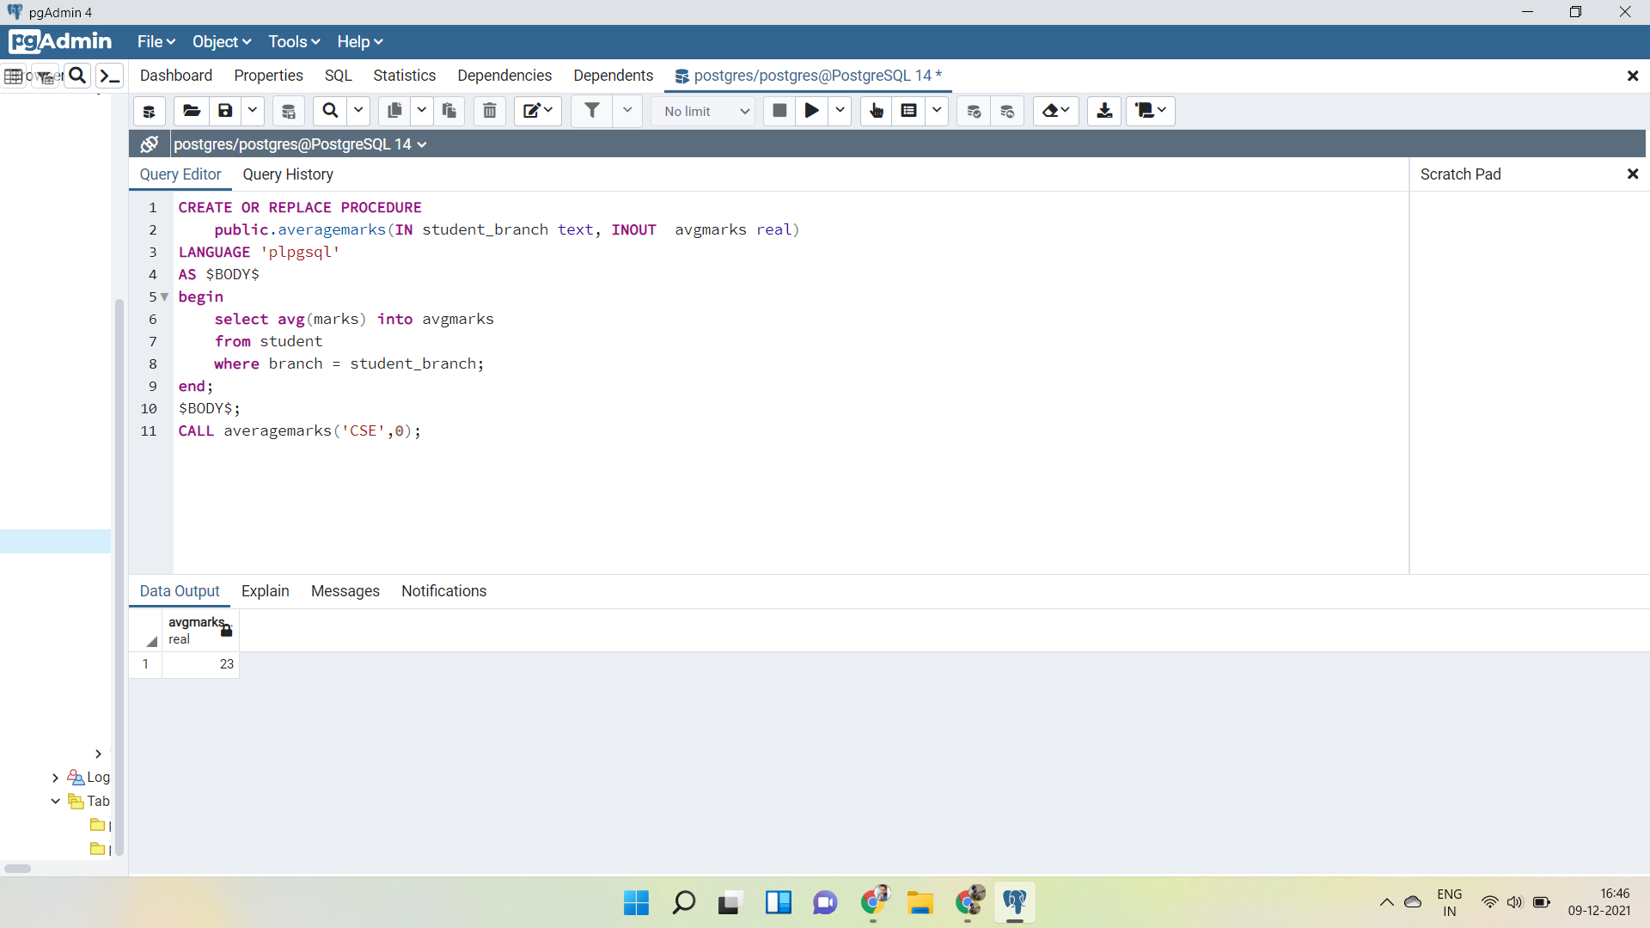

b) Function that accepts branches and returns the total no. of students of the branch.

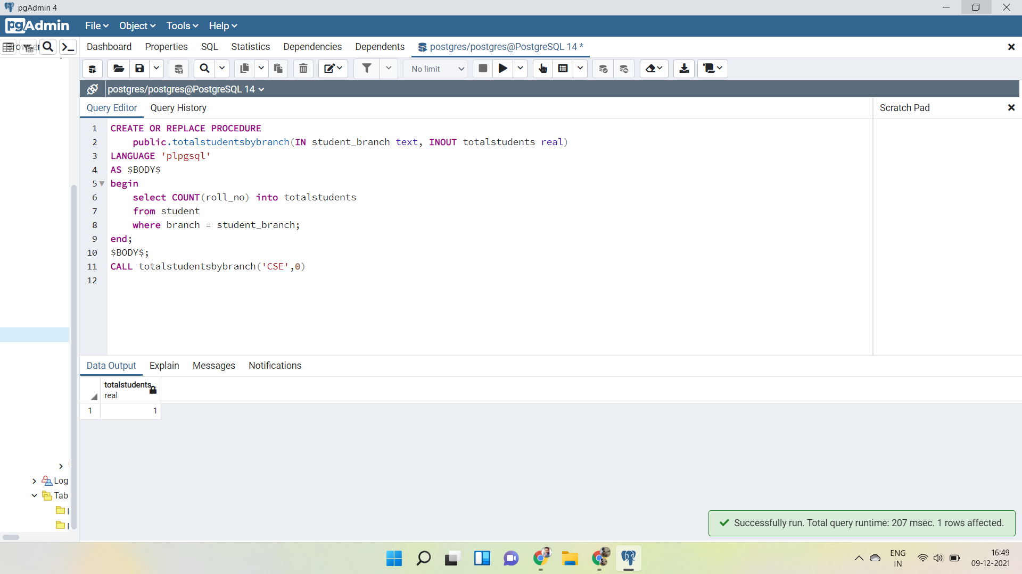

**EXPERIMENT - 8**

**Aim:** Trigger

a. Create a trigger on the table after inserting a new student into the table.

b. Write a row trigger to insert the existing values of the student table into a new table when the marks of the student are updated.

**Theory:**

Trigger is invoked by Oracle engine automatically whenever a specified event occurs.Trigger is stored into database and invoked repeatedly, when specific condition match.

Triggers are stored programs, which are automatically executed or fired when some event occurs.Triggers are written to be executed in response to any of the following events.

A database manipulation (DML) statement (DELETE, INSERT, or UPDATE).

A database definition (DDL) statement (CREATE, ALTER, or DROP).

A database operation (SERVERERROR, LOGON, LOGOFF, STARTUP, or SHUTDOWN).

Triggers could be defined on the table, view, schema, or database with which the event is associated.

Advantages of Triggers

These are the following advantages of Triggers:

* Trigger generates some derived column values automatically
* Enforces referential integrity
* Event logging and storing information on table access
* Auditing
* Synchronous replication of tables
* Imposing security authorizations
* Preventing invalid transactions

The syntax for creating a trigger is −

CREATE [OR REPLACE ] TRIGGER trigger_name

{BEFORE | AFTER | INSTEAD OF }

{INSERT [OR] | UPDATE [OR] | DELETE}

[OF col_name]

ON table_name

[REFERENCING OLD AS o NEW AS n]

[FOR EACH ROW]

WHEN (condition)

DECLARE

Declaration-statements

BEGIN

Executable-statements

EXCEPTION

Exception-handling-statements

END;

**Implementation :**

a. Trigger on the table after inserting a new student into the table.

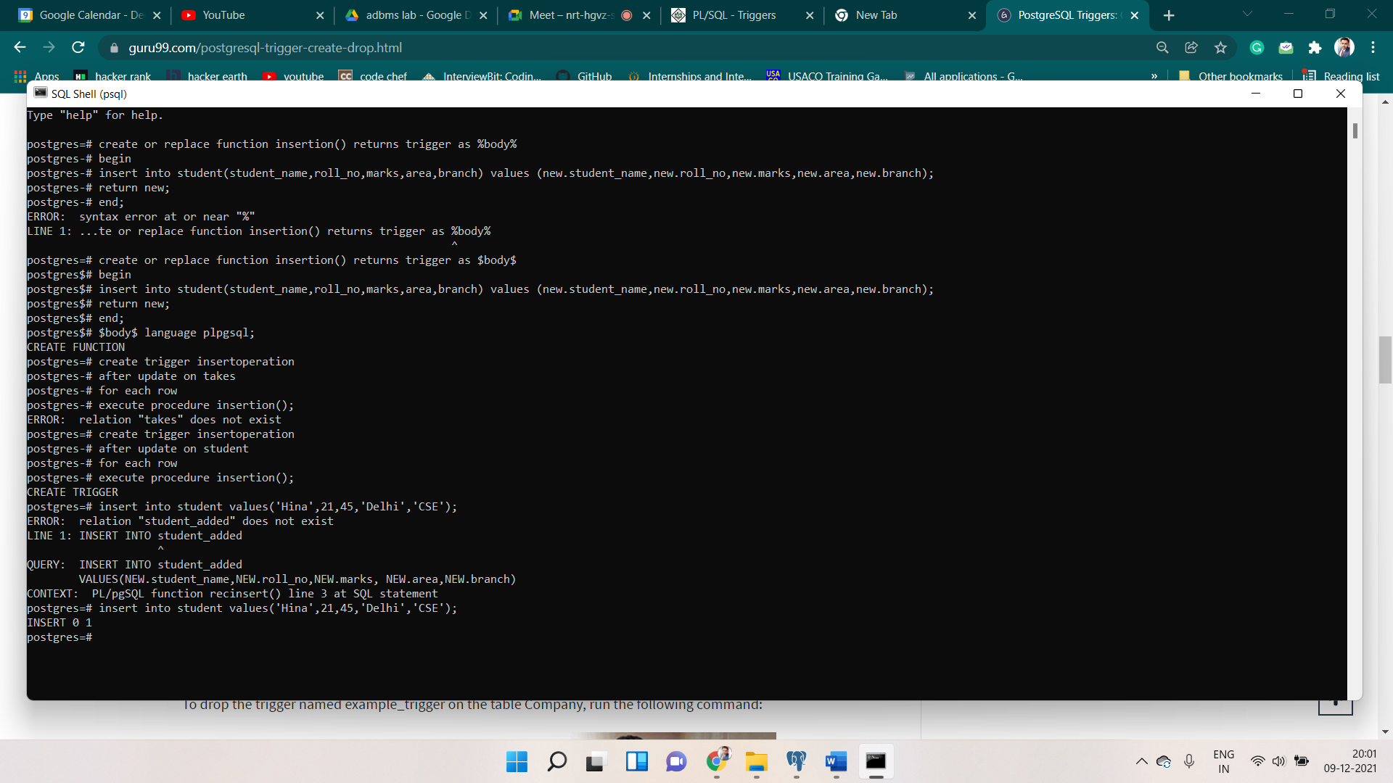





b. Row trigger to insert the existing values of the student table into a new table when the marks of the student are updated.

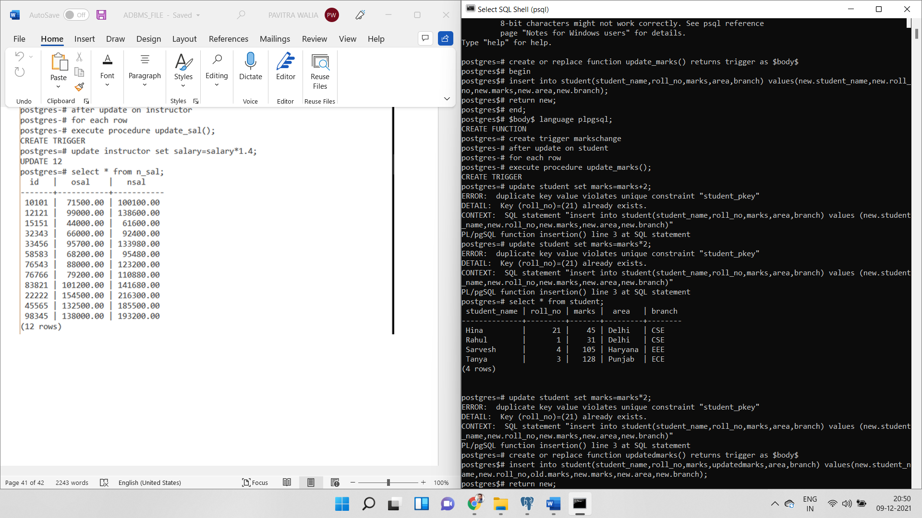



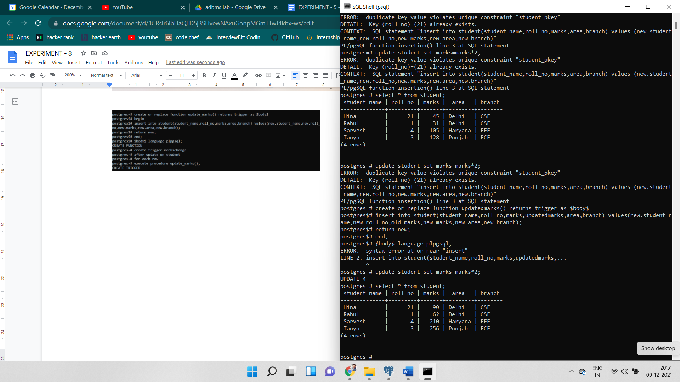

**EXPERIMENT - 9**

**Aim:** Design Database - Inventory Database(represent for purchase/order details).

**Theory:**

the complete steps to design a database schema of the Inventory Management System to manage the customers, items, and purchase orders.

**Table Name: Customers**

Description: Used to store customers information having data ID, first name, last name, and email.

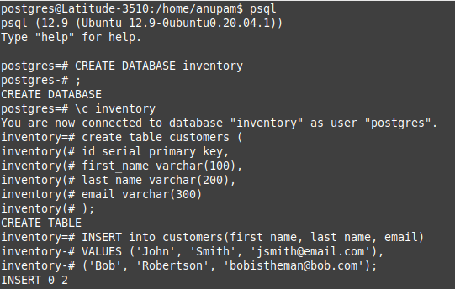

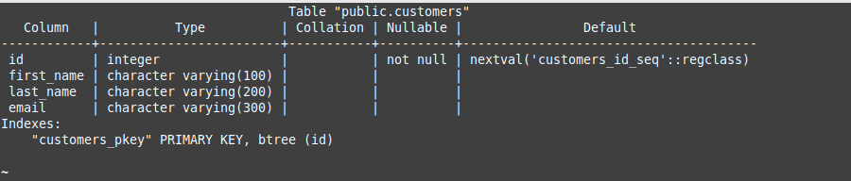

Data:

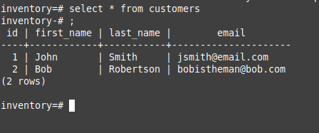

**Table Name: items**

**Description**: It will help in storing the items in the inventory having the values ID, its SKU (unit product id), and inventory(number of pieces).

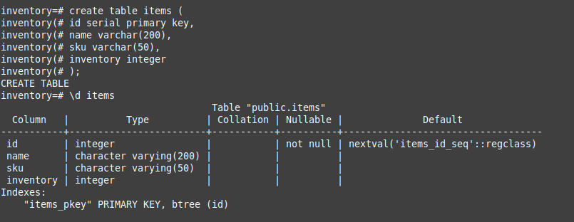

Data:

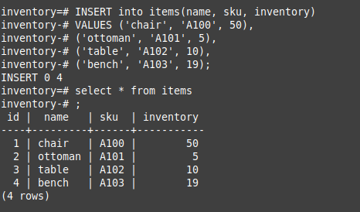

**Table Name: Purchases**

**Description**: It will help in storing the purchases made by the customers in the inventory having the values ID, item_id and purchase_quantity.

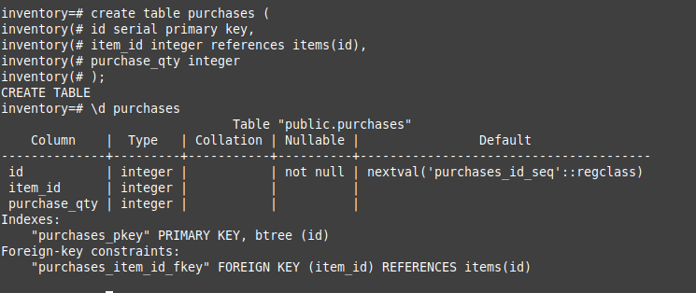

Data:

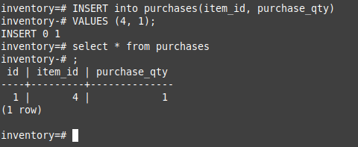

The customer database would handle the data the customers with their personal details, then the inventory items would be stored in the items table, and then the purchases would be able to take up the connection between the purchases made by the customers on the table and the items respectively.